
UNIVERSITY OF GONDAR
COLLEGE OF INFORMATICS
DEPARTMENT OF COMPUTER SCIENCE
FINAL YEAR PROJECT-1
PROJECT TITLE: PERSONAL MOVIE, MUSIC, AND BOOK RECOMMENDATION SYSTEM
Prepared by :
NAME ID NO
- AMANUEL TADESSE ………………………………………………GUR/02606/15
- EYUEL TESHOME………………………………………………… GUR/02321/15
- YOHANNES BIRKU……………………………………………….. GUR/01939/15

Submitted to the Department of Computer Science, Faculty of Informatics, University of Gondar, in meeting the preliminary project requirement for partial fulfillment of the award of Bachelor of Science Degree in Computer Science.
Gondar, Ethiopia
Date/Year: April/2026 G.C

APPROVAL SHEET FORMAT
This Group Project Entitled “PERSONAL MOVIE, MUSIC, AND BOOK RECOMMENDATION SYSTEM” has been Read and Approved as Meeting the Preliminary Project Requirements of the Department of Computer Science in Partial Fulfillment for the Award of Bachelor of Science Degree in Computer Science, University of Gondar, Gondar, Ethiopia.
Approved by
- Name of Advisor:_________________________Signature:_____________Date:________
- Name of Project Coordinator:_ ______________Signature :_____________Date:_______

Acknowledgement
First of all, We would Like to Thank God for Granting Us Strength and Guidance to successfully Complete our task. We extend our deepest Gratitude to our Advisor , Mr. Birhane ,for his invaluable Guidance, insightful Advice, Continuous Supervision Throughout our Work. Finally We would like to express our sincere appreciation to all individuals who provided us with important information and support during this endeavor
Finally, we would like to acknowledge all those who directly or indirectly contributed to the success of this project. Without their help, this work would not have been possible.
TABLE OF CONTENTS
APPROVAL SHEET .......................................................................................................... ii
ACKNOWLEDGEMENT ................................................................................................. iii
TABLE OF CONTENTS ................................................................................................... iv
LIST OF TABLES ........................................................................................................... vi
LIST OF FIGURES .......................................................................................................... vii
ACRONYMS AND ABBREVIATIONS ............................................................................... viii
EXECUTIVE SUMMARY ................................................................................................ ix
CHAPTER ONE: INTRODUCTION ................................................................................. 1
1.1 Background of the Project ........................................................................................ 1
1.2 Statement of the Problem and Justification ................................................................ 2
1.3 Objective of the Project ............................................................................................ 4
1.3.1 General Objective ............................................................................................ 4
1.3.2 Specific Objectives ........................................................................................... 4
1.4 Scope of the Project .................................................................................................. 5
1.5 Limitations of the Project ......................................................................................... 6
1.6 System Development Methodology ............................................................................ 7
1.6.1 System Development Approach ......................................................................... 7
1.6.2 System Development Tools .............................................................................. 8
1.7 Significance of the Project ...................................................................................... 9
1.8 Beneficiaries of the Project .................................................................................... 10
1.9 Feasibility Study ...................................................................................................... 11
1.9.1 Technical Feasibility ...................................................................................... 11
1.9.2 Operational Feasibility ................................................................................... 11
1.9.3 Economic Feasibility ....................................................................................... 12
1.9.4 Legal Feasibility .............................................................................................. 12
1.10 Project Schedule .................................................................................................... 13
1.11 Project Budget ....................................................................................................... 14
CHAPTER TWO: REQUIREMENT ANALYSIS ............................................................. 15
2.1 Current System Description ..................................................................................... 15
2.1.1 Major Functions of Current Systems .................................................................. 15
2.1.2 Problems of Existing Systems ........................................................................... 16
2.2 Requirement Gathering ............................................................................................ 18
2.2.1 Requirement Gathering Methods ....................................................................... 18
2.2.2 Business Rules ................................................................................................ 19
2.3 Proposed System Description ................................................................................... 21
2.3.1 Overview ......................................................................................................... 21
2.3.2 Functional Requirements .................................................................................. 22
2.3.3 Non-Functional Requirements ........................................................................... 23
CHAPTER THREE: SYSTEM MODEL ........................................................................ 25
3.1 Scenario .................................................................................................................. 25
3.2 Use Case Model ...................................................................................................... 26
3.2.1 Actors of the System ....................................................................................... 26
3.2.2 Use Case Scenarios ........................................................................................... 27
3.3 Use Case Diagram ................................................................................................... 29
3.4 Use Case Descriptions ............................................................................................. 30
3.5 Activity Diagrams .................................................................................................... 38
3.6 Data Dictionary ....................................................................................................... 48
3.7 Class Model ............................................................................................................. 58
3.8 Dynamic Modeling ................................................................................................... 59
3.9 User Interface Design .............................................................................................. 63
CHAPTER FOUR: SYSTEM DESIGN ........................................................................... 70
4.1 Introduction ............................................................................................................. 70
4.2 System Architecture ................................................................................................. 71
4.2.1 Three-Tier Architecture Description .................................................................. 71
4.3 System Decomposition .............................................................................................. 73
4.3.1 User Management Subsystem ............................................................................ 73
4.3.2 Content Management Subsystem ........................................................................ 74
4.3.3 Recommendation Engine Subsystem ................................................................... 75
4.3.4 Presentation and Interface Subsystem ................................................................ 76
4.4 Component Diagram ................................................................................................. 77
4.5 Hardware/Software Mapping ..................................................................................... 78
4.6 Persistent Data Modeling .......................................................................................... 79
4.6.1 Database Selection .......................................................................................... 79
4.6.2 Database Schema ............................................................................................. 80
4.6.3 ER Diagram .................................................................................................... 81
4.7 Access Control and Security ................................................................................... 82
4.7.1 Role-Based Access Control (RBAC) ................................................................. 82
4.7.2 Security Implementation Measures ................................................................... 83
4.8 Detailed Class Diagram .......................................................................................... 84
4.9 Package Diagram .................................................................................................... 86
4.10 Deployment ........................................................................................................... 88
REFERENCES ............................................................................................................ 91

LIST OF TABLES

Table 1.1: System Development Tools and Technologies…………..……… 1
Table 1.2: Project Schedule …………..…………………..……………….. 13
Table 1.3: Hardware Cost …………..…………………..……………………. 14
Table 1.4: Software Cost …………..…………………..……………………. 14
Table 1.5: Material Cost …………..…………………..……………………… 14
Table 1.6: Communication Cost …………..…………………..……………… 15
Table 3.1: Use Case Description – Register …………..…………………..… 30
Table 3.2: Use Case Description – Login …………..…………………..……… 31
Table 3.3: Use Case Description – Logout …………..………………………… 32
Table 3.4: Use Case Description - Rate Item …………..…………………..…… 33
Table 3.5: Use Case Description - Get Recommendations …………..………… 34
Table 3.6: Use Case Description - Search Content …………..………………… 35
Table 3.7: Use Case Description - Admin Manage Users …………..…………. 36
Table 3.8: Use Case Description - Admin Add Content …………..…………… 37
Table 3.10: User Table …………..…………………..………………………………. 48
Table 3.11: Item Table …………..…………………..……………………………… 49
Table 3.12: Book-Specific Attributes Table …………..…………………..…….. 50
Table 3.13: Movie-Specific Attributes Table …………..………………….………… 51
Table 3.14: Music-Specific Attributes Table …………..…………………..……… 52
Table 3.15: Rating Table …………..…………………..………………………… 53
Table 3.16: Preference Table …………..…………………..……………………… 54
Table 3.17: Recommendation Table …………..…………………..…………………. 55
Table 3.18: Wishlist Table …………..…………………..……………………………… 56
Table 3.19: Ethiopian Content Metadata Table …………..…………………..………… 57
Table 4.1: Role-Based Access Control (RBAC) Specifications …………..………… 82

LIST OF FIGURES
Figure Page
Figure 3-1 : Use Case Diagram …………..…………………..……………………….28
Figure 3-2 User Login Activity Diagram …………..…………………..…………38
Figure 3-3 User Logout Activity Diagram …………..…………………..………..39
Figure 3-4 Rate Item Activity Diagram …………..…………………..……………40
Figure 3-5 Get Recommendations Activity Diagram …………..………………..…41
Figure 3-6 Search Content Activity Diagram …………..…………………..………42
Figure 3-7 Add to Wishlist Activity Diagram …………..…………………..………43
Figure 3-8 View Wishlist Activity Diagram …………..…………………..………44
Figure 3-9 Ethiopian Content Activity Diagram …………..…………………..…45
Figure 3-10 Admin Add Content Activity Diagram …………..…………………..…46
Figure 3-11 Admin Manage Users Activity Diagram …………..……………………47
Figure 3-12 Class Model Diagram …………..…………………..…………………..59
Figure 3-13 State Chart Diagram…………..…………………..…………..…………60
Figure 3-14 Sequence Diagram for AI Matching Flow …………..…………………60
Figure 3-15 Sequence Diagram for Cross-Domain Recommendation..…….. ………61
Figure 3-16 Sequence Diagram for Get Recommendations …………..……..………62
Figure 3-17 Home Page (Guest View) …………..……………………..……………63
Figure 3-18 User Dashboard (Logged In) …………..…………………..……………64
Figure 3-19 Item Detail Page …………..…………………..………………………..65
Figure 4-1 Component Diagram …………..…………………..…………………..67
Figure 4-2 Hardware/Software Mapping Diagram …………..…………………….67
Figure 4-3 ER Diagram - Part 1 …………..…………………..……………………69
Figure 4-4 ER Diagram - Part 2 …………..…………………..……………………69
Figure 4-5 Detailed Class Diagram 1 …………..…………………..………………74
Figure 4-7 Package Diagram …………..…………………..………………………88
Figure 4-8 Deployment Diagram …………..…………………..…………………..90

ACRONYMS AND ABBREVIATIONS
AI - Artificial Intelligence
API - Application Programming Interface
CSV - Comma-Separated Values
ER - Entity-Relationship
HTML – HyperText Markup Language
HTTP – HyperText Transfer Protocol
HTTPS – HyperText Transfer Protocol Secure
ISBN - International Standard Book Number
JSON - JavaScript Object Notation
JWT - JSON Web Token
ML - Machine Learning
MySQL - My Structured Query Language
ORM - Object-Relational Mapping
PHP - PHP: Hypertext Preprocessor
RBAC - Role-Based Access Control
REST - Representational State Transfer
SQL - Structured Query Language
SSL - Secure Sockets Layer
TLS - Transport Layer Security
TMDB - The Movie Database
UML - Unified Modeling Language
UI - User Interface
UX - User Experience
XSS - Cross-Site Scripting

EXECUTIVE SUMMARY
This project presents the design and development of a Personal Movie, Music, and Book Recommendation System, a web based platform that provides personalized content suggestions across three entertainment domains. The system addresses platform fragmentation, where users must navigate multiple disconnected services to discover books, movies, and music. It also tackles the underrepresentation of Ethiopian content in global recommendation systems by incorporating culturally aware categorization for Amharic literature, Ethiopian films, and traditional music genres such as Tizita and Bati.
The system employs a hybrid recommendation engine combining collaborative filtering and content based algorithms to analyze user ratings and generate personalized suggestions. A three tier architecture separates the React.js frontend, Python Flask backend, and MySQL database. Key features include user registration, content browsing, rating submission, and administrative interfaces for content curation.
Survey data indicates that 86% of potential users would use a unified recommendation platform, with 78% expressing difficulty finding Ethiopian content through existing services. The system directly addresses these needs while maintaining academic rigor in its implementation.
This document details the complete system development lifecycle, including requirements analysis, architectural design, and implementation considerations. The project serves as both a functional recommendation platform and an educational resource demonstrating the practical application of machine learning algorithms, database design, and full stack web development principles.

CHAPTER ONE-INTRODUCTION

1.1 BACKGROUND OF THE PROJECT

The proliferation of digital media has provided users with an unprecedented volume of entertainment options, including millions of published books, released movies, and streaming songs. However, this abundance creates a significant decision-making challenge. Users frequently spend excessive amounts of time navigating multiple platforms, often experiencing decision fatigue before discovering suitable content.

While major platforms employ recommendation systems to assist users, these systems operate in silos. A user's preference history on a movie streaming platform does not inform book or music recommendations elsewhere. Consequently, cross-domain discovery—such as finding a book related to a recently enjoyed film—is unsupported by current mainstream applications.

For Ethiopian users, these challenges are compounded by the inadequate representation and misclassification of local content on global platforms. Traditional Ethiopian music genres, such as Tizita, are frequently mislabeled with generic Western classifications like "sad music." Furthermore, Ethiopian films receive minimal visibility in recommendation algorithms, and Amharic literature is largely absent from international databases. As a result, users are forced to rely on informal discovery channels, such as social media groups and word of mouth, which lack personalization and scalability.

To address these gaps, this project proposes a unified web-based recommendation system that integrates books, movies, and music. The system analyzes user preferences across all three domains and implements a culturally aware algorithm that accurately categorizes and recommends Ethiopian content using contextual and appropriate metadata.

1.2 STATEMENT OF THE PROBLEM AND JUSTIFICATION

Discovering relevant entertainment content currently requires significant user effort due to platform fragmentation. Existing entertainment platforms operate independently, lacking the interoperability required to share user preference data across domains. For instance, a user's high ratings for romance novels on a book platform do not influence movie recommendations on a streaming service.

This issue is particularly acute for Ethiopian users. Global platforms demonstrate a fundamental misunderstanding of local cultural contexts, frequently misclassifying traditional content. For example, the Ethiopian musical genre "Tizita" is often reduced to the generic label of "sad music," failing to capture its cultural and emotional nuance. Similarly, Ethiopian films suffer from low visibility in recommendation algorithms, preventing users from discovering high-quality local content even when it aligns with their preferences.

Additionally, new users face the "cold start" problem, where platforms lack the initial data required to generate personalized suggestions, defaulting instead to generic, globally popular content. User preference data remains scattered across disparate accounts, preventing a holistic understanding of individual tastes. Furthermore, Ethiopian users face socio-technical barriers, including bandwidth limitations, subscription costs, and a lack of localized language support.

To resolve these issues, this project proposes a unified platform where users can discover books, movies, and music without switching applications. The system learns cross-domain preferences and provides Ethiopian content with the visibility it deserves. For everyday users, this means less time searching and more time enjoying content. For Ethiopian creators, their work becomes discoverable. For the university, it demonstrates the capability to build artificial intelligence tools that solve localized problems rather than relying solely on foreign solutions.

1.3 OBJECTIVE OF THE PROJECT

1.3.1 General Objective

To design, develop, and implement an intelligent recommendation system that provides personalized suggestions for books, movies, and music using AI and machine learning, with special focus on Ethiopian content.

1.3.2 Specific Objectives
- To develop a unified content database that integrates books, movies, and music (including Ethiopian works such as Amharic books, Ethiopian films, and traditional music like Tizita) into a single searchable and rateable platform.
- To implement a cross-domain collaborative filtering algorithm that learns user preferences across all three media types (e.g., recommending a movie based on a previously rated book or song).
- To design and integrate a cold-start handling mechanism that provides meaningful initial recommendations to new users without requiring extensive prior ratings or history.
- To build an Ethiopian-content-aware recommendation module that correctly classifies and recommends local content (e.g., labeling Tizita as a distinct Ethiopian mood-based genre rather than “sad music”) and improves visibility of Ethiopian films and books.
- To create a lightweight web-based user interface optimized for Ethiopian users, including low-bandwidth support, no mandatory subscription costs, and an optional Amharic language interface.
- To evaluate the system’s performance using standard recommendation metrics (precision, recall, and user satisfaction) specifically measuring improvement in discovery time and relevance of Ethiopian content compared to existing global platforms.

1.4 SCOPE OF THE PROJECT
The proposed system is a web-based platform designed for discovering movies, music, and books. It encompasses three primary modules: a User Dashboard for personalized recommendations, an Admin Interface for content and user management, and a Guest View for unregistered visitors to browse popular content. Users build entertainment profiles by rating items, which the hybrid recommendation engine uses to generate suggestions. A dedicated Ethiopian Content Module ensures local media is properly categorized and recommended alongside international content. The system is self-contained, featuring an independent database and authentication mechanism, and is deployable on university servers, personal hosting, or cloud environments without requiring integration with external institutional systems.

1.5 LIMITATIONS OF THE PROJECT

The scope of this project is subject to certain limitations. The system functions strictly as a recommendation engine and does not integrate with streaming services (e.g., Netflix, Spotify) to provide direct content playback; users must source the actual media independently. Social features, such as friend connections and content sharing, are excluded from the current scope. The platform is developed as a web application; a dedicated mobile application is not included. The recommendation engine utilizes standard collaborative and content-based filtering algorithms, excluding advanced deep learning models. Finally, while the system supports Ethiopian content, the initial database will not be exhaustive and will require ongoing administrative expansion post-launch.

1.6 SYSTEM DEVELOPMENT METHODOLOGY

1.6.1 System Development Approach

We chose the Hybrid Iterative and Incremental Model for this project. It fits our modular design and the fact that our recommendation algorithms need constant tweaking.

Why Incremental? Our system has three main parts: the User Dashboard, the Admin Panel, and the Guest View. We built and tested each part separately. First we built User Registration and Authentication. Then Content Management. Then the Rating Module. Finally, we added the Recommendation Engine. This way, if something broke, we did not lose everything.

Why Iterative? The recommendation logic needs a lot of trial and error. In our first attempt, collaborative filtering worked but felt basic. We kept going back, adding content-based filtering, fixing cold start problems, and improving cross-domain connections. The iterative model let us improve the algorithm over time without breaking what already worked.

Development Sprints

We worked in six sprints of about four weeks each. Sprint 1 was requirements and design. Sprint 2 was data collection and API integration. Sprint 3 was backend development. Sprint 4 was frontend development. Sprint 5 was AI integration and algorithm tuning. Sprint 6 was testing, bug fixes, and documentation.
Development Sprints Overview:
Sprint | Duration | Focus Area | Key Deliverables
Sprint 1 | Weeks 1-4 | Requirements & Design | Project proposal, requirement document, UI/UX Project prototypes
Sprint 2 | Weeks 1-4 | Data Collection | Database design, API integration, Ethiopian content collection
Sprint 3 | Weeks 9-12 | Backend Development | User authentication, API endpoints, database connection
Sprint 4 | Weeks 13-16 | Frontend Development | User interfaces, search and browse, rating functionality
Sprint 5 | Weeks 17-20 | AI Integration | Recommendation algorithms, testing and refinement
Sprint 6 | Weeks 21-24 | Testing & Documentation | System testing, user manuals, final documentation

1.6.2 System Development Tools
To build the Personal Movie, Music, and Book Recommendation System, a combination of modern and reliable technologies was utilized. These tools were selected to ensure the system's scalability, security, and the effective implementation of the AI-driven recommendation engine.
Table 1.1: System Development Tools and Technologies
Category | Tool/Technology | Purpose and Application
Documentation | Microsoft Word | To facilitate collaborative writing and version control of project documentation and technical reports
System Design | Draw.io | To model system architectures, including Use Case diagrams, ER diagrams, and sequence diagrams
Frontend Development | React.js | Chosen for its component-based architecture to develop dynamic, responsive user interfaces for students and administrators
Backend Development | Python with Flask | To engineer a robust server-side environment capable of managing API services and the core recommendation logic
Database | MySQL | A relational database selected for its reliability in storing structured user profiles, content items, and rating data
AI/ML Libraries | scikit-learn, Pandas, NumPy | Utilized to implement collaborative filtering, content-based algorithms, and similarity calculations
Version Control | GitHub | Employed for collaborative source code management, branch tracking, and maintaining the project's development history
UI/UX Design | Figma | To create high-fidelity prototypes and wireframes for the User Dashboard and Admin Panel before actual development
API Testing | Postman | For testing backend APIs during development before frontend integration
Data Sources | Google Books API, TMDB API, Spotify API | To populate the database with book, movie, and music metadata efficiently

1.7 SIGNIFICANCE OF THE PROJECT
The system eliminates platform fragmentation by unifying book, movie, and music discovery into a single platform, learning preferences across all three domains to save user time and reduce frustration. For Ethiopian creators, the system provides proper visibility for local media that is frequently lost or mislabeled on global platforms, thereby helping to preserve and promote Ethiopian culture digitally. For students and the University of Gondar, the project translates theoretical AI concepts into a functional system, demonstrating that practical, localized technological solutions can be engineered within the academic community.
1.8 BENEFICIARIES OF THE PROJECT
- Regular Users: Benefit from personalized cross-domain recommendations in one place, reducing decision fatigue.
- Ethiopian Content Consumers: Gain an accessible way to discover local books, films, and music that global platforms fail to provide, strengthening cultural connection.
- Ethiopian Content Creators: Benefit from increased visibility, reaching audiences who genuinely appreciate their work.
- Computer Science Students/Researchers: Benefit from a documented example of a recommendation system implementation bridging theory and practice.
- University of Gondar: Benefits from a project that enhances the department's reputation for community-relevant technology.
1.9 FEASIBILITY STUDY
Technical Feasibility
The system utilizes open-source, well-documented technologies (React.js, Flask, MySQL) requiring no licensing fees or specialized hardware. The recommendation algorithms employ proven, lightweight approaches (cosine similarity, Pearson correlation, TF-IDF) capable of running on standard laboratory computers using scikit-learn. The team possesses the requisite programming and database skills. No technical barriers prevent successful completion.
Operational Feasibility
The system automates a process that currently relies on manual, fragmented discovery. Survey data indicates that 86% of respondents would use a unified recommendation platform. The interface requires no technical training for regular users, and administrators only need basic computer literacy. The system aligns with existing user behaviors and solves a recognized frustration.
Legal Feasibility
The system complies with intellectual property laws and API terms of service. External APIs are used strictly for non-commercial educational purposes, storing metadata rather than copyrighted content. User data is minimized, passwords are secured with bcrypt hashing, and no third-party data sharing occurs. All software tools possess appropriate open-source licenses.
Economic Feasibility
Development costs are minimal as core technologies are free. Labor costs are absorbed by the team as part of academic requirements. Operational costs remain low, as the platform can be hosted on university servers or free-tier cloud environments. The project yields high non-financial returns in user time savings and cultural visibility.
1.10 PROJECT SCHEDULE
The project schedule defines the strategic timeline for each phase of the system development. It serves as a critical project management tool for tracking milestones and ensuring timely completion of deliverables.
The project progresses from initial requirement gathering through system design, implementation, testing, deployment, and final defense preparation. Each phase has clearly defined deliverables and deadlines, allowing the team to monitor progress and manage academic resources effectively. The schedule ensures that all components including the frontend, backend, database, and recommendation engine are completed in a coordinated manner leading to the final project submission.
Table 1.2: Project Schedule
Phase | Activity Description | Planned Dates
Phase 1 | Project Initiation & Planning | Dec 24 – Jan 07, 2026
Phase 2 | Requirements Analysis &Documentation | Jan 08 – Jan 21, 2026
Phase 3 | System Design & UI/UX Prototyping | Jan 22 – Feb 11, 2026
Phase 4 | Data Collection & API Integration | Feb 12 – Mar 04, 2026
Phase 5 | Backend Development | Mar 05 – Apr 15, 2026
Phase 6 | Frontend Development | Apr 16 – May 06, 2026
Phase 7 | AI Engine Development | May 07 – Jun 10, 2026
1.11 PROJECT BUDGET
The project budget provides an itemized breakdown of the estimated financial resources required to implement the Personal Movie, Music, and Book Recommendation System successfully. It includes all expected costs, such as hardware, software, materials, and other essential resources. This budget ensures that the project remains within financial constraints while covering all necessary components for development and deployment. The goal is to allocate the budget efficiently, allowing for the smooth execution of the project and ensuring that no critical aspects are overlooked.
NO | Item name | Quantity | Price/Unit(Birr) |  | Total price
1 | Flash Drive 64GB | 1 | 500 |  | 500
2 | Laptops (Existing Hardware) | 2 | 0 |  | 0
Total |  |  |  |  | 500
Table 1.3 Hardware cost

NO | Item Name | Price
1 | VS Code Editor | Free
2 | MySQL Workbench | Free
3 | Draw.io/Figma | Free
Table 1.4 Software cost
NO | Item name | Quantity | Price/Unit(Birr) | Total price
1 | Pen | 3 | 25 | 75
2 | A4 Paper (Ream) | 50 | 5 | 250
Total Price |  |  |  | 325
Table 1.5 Material Cost
NO | For phone calls and Data | Cost(Birr)
1 | With our team members | 100
2 | With our advisor | 50
Total Price |  | 150
Table 1.6Communication Cost
Total Estimated Project Cost = Hardware + Software + Material + Communication
= 500 + 0 + 325 + 150 = 975 Birr

CHAPTER TWO: REQUIREMENT ANALYSIS
2.1 Current System Description
An investigation was conducted to understand how users currently discover books, movies, and music, examining both global platforms and the specific discovery behaviors at the University of Gondar. The findings indicate that there is no formal, unified system in place; instead, users employ a fragmented approach where discovery methods vary significantly across media domains.
2.1.1 Major Functions of Current Systems
Currently, users rely on a combination of global platforms and informal channels to discover entertainment content. The major functions of these existing methods include:
- Keyword Search and Browsing: Platforms like Goodreads, IMDb, and Spotify allow users to search for content by title, author, or genre.
- Algorithmic Suggestions (Single Domain): Services like Netflix and YouTube provide recommendations based on a user's viewing history, but these are strictly confined to their specific media type.
- Aggregated Ratings: Global platforms display aggregated user ratings to help users gauge the quality of content.
- Informal Social Sharing: Ethiopian students heavily rely on Telegram channels, Facebook groups, and peer recommendations to share links and discover new local content, functioning as a manual, social recommendation system.
2.1.2 Problems of Existing Systems
Through observation, surveys, and interviews, several critical problems with the current discovery ecosystem were identified:
- Platform Fragmentation: Users must maintain accounts across multiple platforms to cover their entertainment interests. None of these platforms share preference data, meaning a user's reading history does not inform their movie or music suggestions.
- Underrepresentation of Ethiopian Content: Global platforms fail to understand Ethiopian cultural contexts. For example, the traditional music genre "Tizita" is frequently misclassified as generic "sad" or "slow" music by Western algorithms, resulting in irrelevant recommendations. Amharic literature often lacks ISBNs and is entirely absent from global databases.
- The Cold Start Problem: New users on global platforms receive generic, globally popular recommendations that do not reflect local preferences. Without initial guidance, users abandon these platforms in favor of word-of-mouth.
- Lack of Adaptability: As user tastes evolve over time, existing platforms lack straightforward mechanisms for users to indicate changed interests or depreciate older preferences.
- High Data Consumption: Browsing recommendations on media-heavy platforms consumes significant bandwidth, a practical constraint for students managing limited data plans.
- Lack of Creator Discovery Mechanisms: For Ethiopian authors, filmmakers, and musicians, there are no structured discovery mechanisms to connect their work with potential audiences, leaving quality content undiscovered.
2.2 Requirement Gathering
2.2.1 Requirement Gathering Methods
To identify accurate system requirements, multiple data collection methods were employed:
- Direct Observation: Eight students from various departments were observed while searching for new content. Observations revealed an average search time of 22 minutes, with users visiting 3 to 4 platforms per session. Five out of eight students abandoned their searches to default to familiar content.
- Structured Questionnaire: A survey distributed through university groups received 47 responses. Key findings indicated that 89% of respondents discover content through friend recommendations, and 83% use social media. Furthermore, 74% reported that platform recommendations do not understand their actual preferences, and 62% noted Ethiopian content is difficult to find. 86% expressed positive interest in a unified recommendation platform.
- Interviews: Extended interviews with six individuals revealed consistent frustrations regarding the misclassification of Ethiopian content and the desire for cross-domain connections (e.g., finding a movie related to a book).
- Document Analysis: Existing platforms (Netflix, Spotify, Goodreads) were analyzed, confirming that no current platform addresses unified discovery across domains while handling Ethiopian content accurately.
2.2.2 Business Rules
The business rules govern system behavior and user interaction:
- User Registration: Users must register with a valid university email address to access personalized features.
- Profile Activation & Cold Start Mitigation: Upon first login, new users must complete an onboarding preference survey, selecting their favorite genres, moods, and specific Ethiopian cultural preferences (e.g., Tizita, Amharic literature) across books, movies, and music. This initial data seeds the user's preference profile, allowing the system to generate immediate recommendations and bypassing the traditional cold-start problem.
- Rating System: Users may rate items on a 1 to 5 scale (with half-star increments). Users may update or delete ratings, triggering an automatic refresh of the recommendation engine.
- Negative Signaling: Users may mark items as "Not Interested," which applies negative weight in the recommendation algorithm.
- Ethiopian Content Handling: Ethiopian music genres (Tizita, Bati, Anchihoye) are treated as distinct, primary categories, not sub-genres of Western classifications. Ethiopian content receives a moderate weighting boost in calculations to enhance discoverability.
- Privacy: User rating history and preference profiles are strictly confidential, not shared with third parties, or used for advertising. Sessions expire after 30 minutes of inactivity.
2.3 Proposed System Description
2.3.1 Overview
Based on the identified problems and gathered requirements, the proposed Personal Movie, Music, and Book Recommendation System is a unified web application. It provides cross-domain recommendations, ensuring that preferences in books inform movie and music suggestions. The system incorporates culturally aware Ethiopian content handling, accurately categorizing local genres and literature. It addresses the cold-start problem through onboarding surveys and provides a lightweight, data-efficient interface tailored for users with bandwidth constraints.
2.3.2 Functional Requirements
The following defines what the proposed system must do:
- FR-01: The system shall allow users to register, log in, and manage their profiles.
- FR-02: The system shall present an onboarding survey to new users upon their first login, allowing them to select preferred genres, categories, and cultural interests to initialize their recommendation profile.
- FR-03: The system shall allow users to search, browse, and filter content by domain (book, movie, music), genre, year, and origin (Ethiopian/International).
- FR-04: The system shall allow users to rate items on a 1 to 5 scale and mark items as "Not Interested."
- FR-05: The system shall generate personalized, hybrid recommendations using collaborative and content-based filtering algorithms.
- FR-06: The system shall provide cross-domain recommendations (e.g., suggesting a movie based on a rated book).
- FR-07: The system shall provide an explanation for each recommendation (e.g., "Because you liked [Item]").
- FR-08: The system shall allow administrators to manually add, update, and manage Ethiopian content metadata that is missing from external APIs.
- FR-09: The system shall allow administrators to manage user accounts and view basic system analytics.
- FR-10: The system shall fetch and update international content metadata automatically via Google Books, TMDB, and Spotify APIs.
2.3.3 Non-Functional Requirements
The following defines the operational qualities and characteristics of the proposed system, as required by the UoG guideline:
- Performance: The system shall generate and display personalized recommendations within 3 seconds. Web pages shall load in under 2 seconds on a standard university internet connection.
- Scalability: The system architecture shall support an increase in user base and content database size by up to 200% without significant degradation in recommendation generation speed.
- Availability: The system shall target 99% uptime, ensuring accessibility for users except during scheduled maintenance windows.
- Reliability: The recommendation engine shall consistently produce the same results for the same user profile state. The system shall handle API failures gracefully, displaying cached data rather than crashing.
- Maintainability: The system shall utilize a modular three-tier architecture, allowing updates to the frontend, backend, or database independently. Code shall be version-controlled using Git.
- Security: User passwords shall be hashed using bcrypt. Authentication shall be managed via secure JSON Web Tokens (JWT). The system shall implement Role-Based Access Control (RBAC) to separate user and admin privileges and protect against Cross-Site Scripting (XSS) and SQL Injection.
- Environmental: The system shall be a web-based application accessible via standard modern browsers (Chrome, Firefox, Edge) without requiring local installation. It shall be optimized for low-bandwidth environments by minimizing heavy image auto-loading.
- Usability: The user interface shall be intuitive, requiring no technical training. Navigation shall allow a user to find a recommendation or rate an item within 3 clicks from the dashboard.
- Interoperability: The backend shall expose RESTful APIs, allowing the React.js frontend to communicate seamlessly. The system shall successfully parse JSON data from external third-party APIs (TMDB, Spotify, Google Books).

CHAPTER THREE: SYSTEM MODEL
3.1 Scenario
A scenario represents a specific instance of a use case, illustrating a concrete sequence of actions and interactions between the system and its actors. In the context of the Personal Movie, Music, and Book Recommendation System, scenarios validate functional requirements by demonstrating step-by-step how the system responds to various user behaviors, such as a new user registering or a returning user receiving cross-domain recommendations. These scenarios clarify requirement dependencies—such as how user ratings directly influence the AI recommendation logic—and establish a foundation for deriving test cases and sequence diagrams.

3.2 Use Case Model
The Use Case Model provides a high-level blueprint of the system's functional boundaries. It describes how external actors interact with the system to achieve specific goals, outlining user objectives, system responses, and behavioral constraints. This model forms the foundational framework for the system's design, analysis, and test case definition.
3.2.1 Actors of the System
The operating environment of the system is defined by interactions between human actors, external systems, and the proposed application. The system identifies four primary actors:
User: The primary beneficiary of the system, seeking personalized entertainment recommendations. Their interactions include registering and maintaining a profile, rating items across all domains to build a preference profile, receiving and interacting with AI-generated recommendations, and exploring Ethiopian content.
Guest: An unregistered visitor exploring the system before creating an account. Their interactions are limited to viewing popular content, browsing general information, and assessing the platform's value. Their primary goal is evaluating the system before committing to registration.
Administrator: The entity responsible for managing the system's content and user base. Their interactions include manually adding and categorizing Ethiopian content (which external APIs miss), managing user accounts, ensuring data quality, and monitoring system analytics.
3.2.2 Use Case Scenarios
The following scenarios illustrate concrete instances of system interaction:
Scenario 1: New User Onboarding: A guest registers and logs in for the first time. Instead of a blank dashboard, the system redirects the user to an Onboarding Survey. The user selects "Romance" for books, "Drama" for movies, and "Tizita" for music. The system saves these selections as implicit positive ratings, generating an immediate, personalized recommendation feed rather than generic popular content.
Scenario 2: Returning User Receiving Recommendations: A registered user logs in and is redirected to their personalized dashboard. The system retrieves the user's rating history and activates the hybrid recommendation engine. The system generates and displays cross-domain recommendations, each accompanied by an explanation (e.g., "Because you liked [Item]"). The user clicks a recommendation, views its details, and adds it to their wishlist.
Scenario 3: Administrator Adding Ethiopian Content: The administrator logs into the admin panel and selects "Add New Content." After specifying the content type, the administrator checks the "Ethiopian Content" flag, which reveals specific cultural metadata fields (e.g., Tizita genre). The system saves the new entry to the database with the appropriate cultural tags, ensuring it will be processed correctly by the recommendation engine.
Scenario 4: User Rating Triggering AI Update: A user navigates to a previously viewed movie and submits a 5-star rating. The system validates the input, updates the item's average rating, and modifies the user's preference profile. The system then triggers an asynchronous process to recalculate the user's recommendations based on this new data point.
Scenario 5: Guest Conversion: A guest browses the homepage and notices a featured section for Ethiopian content. Upon clicking an Amharic book, the system displays the details but restricts the rating functionality, prompting the user to log in. Impressed by the localized content, the guest clicks "Register," creates an account, and is redirected to a personalized onboarding survey.
3.1.3 USE CASE DIAGRAM

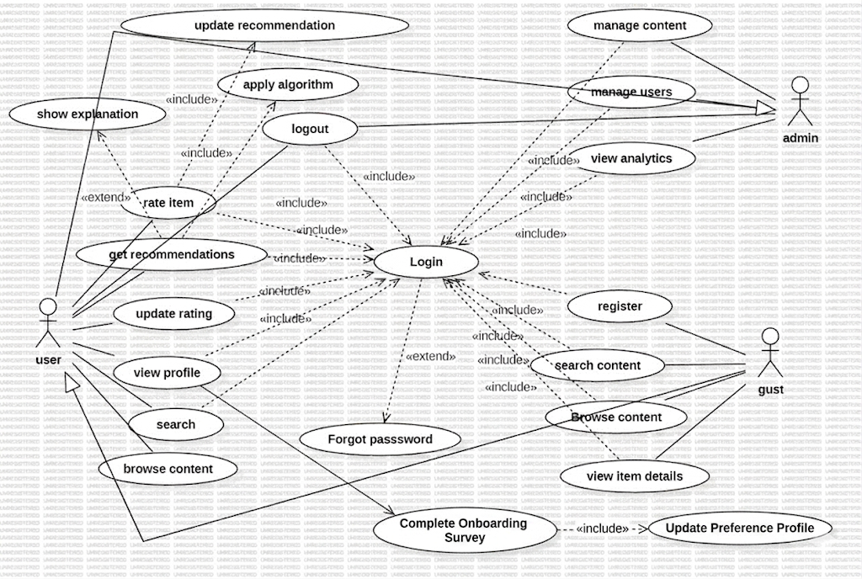
Figure 3-1 Use Case Diagram
3.1.3 DESCRIPTION OF USE CASE MODEL
Use Case Description
The Use Case Description section provides a detailed explanation of how different users interact with the Personal Movie, Music, and Book Recommendation System. Each use case outlines a specific functionality of the system, describing the interactions between key actors (Users, Guests, and Administrators) and the system to achieve a particular objective, such as creating an account, rating an item, or receiving personalized recommendations.
This section includes key elements such as:
- Use Case Name - The title of the use case that defines the functionality
- Description - A brief explanation of the purpose and scope of the use case
- Actors - The users or external systems that participate in the interaction
- Preconditions - The conditions that must be met before the use case starts
- Postconditions - The state of the system after the use case execution
- Basic Course of Action - The standard flow of events in the use case
- Alternative Course of Action - Deviations or exception scenarios that may occur (e.g., invalid input, account suspension, or database errors)
These descriptions offer a structured overview of the system's functionalities, ensuring that all interactions—particularly the AI recommendation logic and personalized features—are well-documented and understood. This is essential for system design, development, and validation, as it helps in identifying user needs, system responses, and potential improvements.
Table 3.1: Use Case Description Register
Use Case Name | Register
Description | This use case allows a guest to create a new user account in the system by providing necessary personal information. Upon successful registration, the user is automatically logged in and redirected to their dashboard.
Actors | Guest
Precondition | 1. The guest is not logged into the system.  2. The guest's email is not already registered in the database
Postcondition | 1. A new user account is created in the database with the provided information.  2. The user's password is securely hashed and stored.  3. The user is authenticated and a session is created.  4. The user is redirected to their personalized dashboard.
Basic Course of Action | 1. The guest navigates to the registration page by clicking "Register" or "Sign Up" on the homepage or login page.  2. The system displays a registration form requesting name, email, password, and password confirmation.  3. The guest enters their full name, email address, and password, then confirms the password.  4. The guest clicks the "Register" or "Create Account" button.  5. The system validates that all required fields are filled and that the email format is correct.  6. The system checks if the password meets minimum strength requirements (at least 8 characters, containing letters and numbers).  7. The system verifies that the password and confirmation match.  8. The system checks the database to ensure the email is not already registered.  9. The system hashes the password using bcrypt with appropriate salt rounds.  10. The system creates a new user record in the database with status "active" and role "user".  11. The system creates a session for the new user using JWT and sets session cookies.  12. The system redirects the user to their personalized dashboard.  13. The system displays a welcome message.
Alternative Course of Action | 1. Invalid Email Format: If the email format is invalid, the system displays an error message "Please enter a valid email address" and highlights the email field.  2. Weak Password: If the password does not meet strength requirements, the system displays "Password must be at least 8 characters and contain both letters and numbers" and prompts the user to choose a stronger password.  3. Password Mismatch: If the password and confirmation do not match, the system displays "Passwords do not match" and highlights both password fields.  4. Email Already Exists: If the email is already registered, the system displays "This email is already registered. Please login or use a different email." and provides links to login or password recovery.  5. Missing Required Fields: If any required field is empty, the system displays "All fields are required" and highlights the empty fields.  6. Database Error: If a database error occurs during account creation, the system displays "Registration failed. Please try again later." and logs the error for administrator review.

Table 3.2: Use Case Description – Login
Element | Description
Use Case Name | Login
Description | This use case allows registered users to authenticate into the system.
Actors | User, Administrator
Precondition | User has registered account. Account is active.
Postcondition | User is authenticated. Session is created.
Basic Course of Action | 1. User clicks "Login".  2. System displays login form.  3. User enters email and password.  4. User clicks "Login".  5. System validates credentials.  6. System checks account status.  7. System creates session.  8. System redirects to dashboard.
Alternative Course of Action | 1. Invalid credentials: System displays error.  2. Account suspended: System shows message.
Table 3.3: Use Case Description - Logout
Use Case Name | Rate Item
Description | This use case allows authenticated users to securely end their session
Actors | User, Administrator
Precondition | User is logged in with active session.
Postcondition | Session is destroyed. User is redirected to homepage.
Basic Course of Action | 1. User clicks "Logout".  2. System destroys session.  3. System redirects to homepage.
Alternative Course of Action | None.
Table 3.4: Use Case Description - Rate Item
Element | Description
Use Case Name | Rate Item
Description | This use case allows a user to rate a book, movie, or music item.
Actors | User
Precondition | User is logged in. Item exists.
Postcondition | Rating is saved. Recommendations are updated.
Basic Course of Action | 1. User views item details.  2. User selects star rating.  3. User clicks "Submit".  4. System saves rating.  5. System updates average rating.  6. System updates user preferences.  7. System triggers recommendation refresh.
Alternative Course of Action | 1. No rating selected: System shows error.  2. Updating existing rating: System updates record.

Table 3.5: Use Case Description - Get Recommendations
Use Case Name | Get Recommendations
Description | This use case generates personalized recommendations using AI.
Actors | User, System (AI Engine)
Precondition | User is logged in. User has rated at least 5 items.
Postcondition | Personalized recommendations are displayed.
Basic Course of Action | 1. User goes to dashboard.  2. System retrieves user's ratings.  3. System runs collaborative filtering.  4. System runs content-based filtering.  5. System combines scores (hybrid).  6. System ranks items by score.  7. System displays recommendations.
Alternative Course of Action | 1. Less than 5 ratings: System shows popular items.

Table 3.6 Use Case Description - Search Content
Use Case Name | Search Content
Description | This use case allows users to search for specific items.
Actors | User, Guest, Administrator
Precondition | None.
Postcondition | Search results are displayed.
Basic Course of Action | 1. User enters search query.  2. User clicks "Search".  3. System searches database.  4. System displays results.
Alternative Course of Action | 1. No results: System shows "No results found".
Table 3.7 Use Case Description - Admin Manage Users
Use Case Name | Manage Users
Description | Administrator manages user accounts.
Actors | Administrator
Precondition | Admin is logged in.
Postcondition | User accounts are updated.
Basic Course of Action | 1. Admin selects "Manage Users".  2. System displays user list.  3. Admin selects user.  4. Admin chooses action (suspend/activate/delete).  5. Admin confirms.  6. System updates database.
Alternative Course of Action | 1. Cancellation: No changes made.
Table 3.8 Use Case Description - Admin Add Content
Use Case Name | Add Content
Description | Administrator adds new books, movies, or music.
Actors | Administrator
Precondition | Admin is logged in.
Postcondition | New content is added to database.
Basic Course of Action | 1. Admin selects "Add Content".  2. Admin chooses type.  3. Admin fills form.  4. Admin clicks "Save".  5. System validates and saves.
Alternative Course of Action | 1. Validation fails: System shows errors.
Use Case Name |  | Complete Onboarding Survey
Description |  | Allows a new user to select initial preferences across books, movies, and music to solve the cold-start problem.
Actors |  | User
Precondition |  | 1. The user has just registered and is logging in for the first time.
Postcondition |  | 1. The user's preference profile is seeded with initial data.  2. The system generates preliminary recommendations.
Basic Course of Action |  | 1. The system redirects the new user to the onboarding survey page.  2. The system displays genre/mood cards for Books, Movies, and Music (including Ethiopian categories).  3. The user selects at least 3 preferences.  4. The user clicks "Start Discovering".  5. The system converts these selections into implicit positive weights.  6. The system updates the user's preference profile.  7. The system redirects the user to their populated dashboard.
Basic Course of Action |  | 3a. User skips survey: The system assigns generic popularity-based recommendations until manual ratings are collected.

Table 3.9 Use Case Description – Complete Onboarding Survey

3.2 ACTIVITY DIAGRAM
The Activity Diagram is a key behavioral UML diagram that illustrates the system's dynamic workflow. It visually represents how activities flow from one step to another, showing the interactions between Users, Guests, Administrators, and the System. These diagrams use swimlanes to differentiate the responsibilities of each actor, grouping activities based on their involvement.
Each Use Case previously identified corresponds to a specific workflow, which is detailed using Activity Diagrams. These diagrams help in understanding the sequential flow of activities, decision points, and interactions within the sy
3.2.1User Registration Activity Diagram

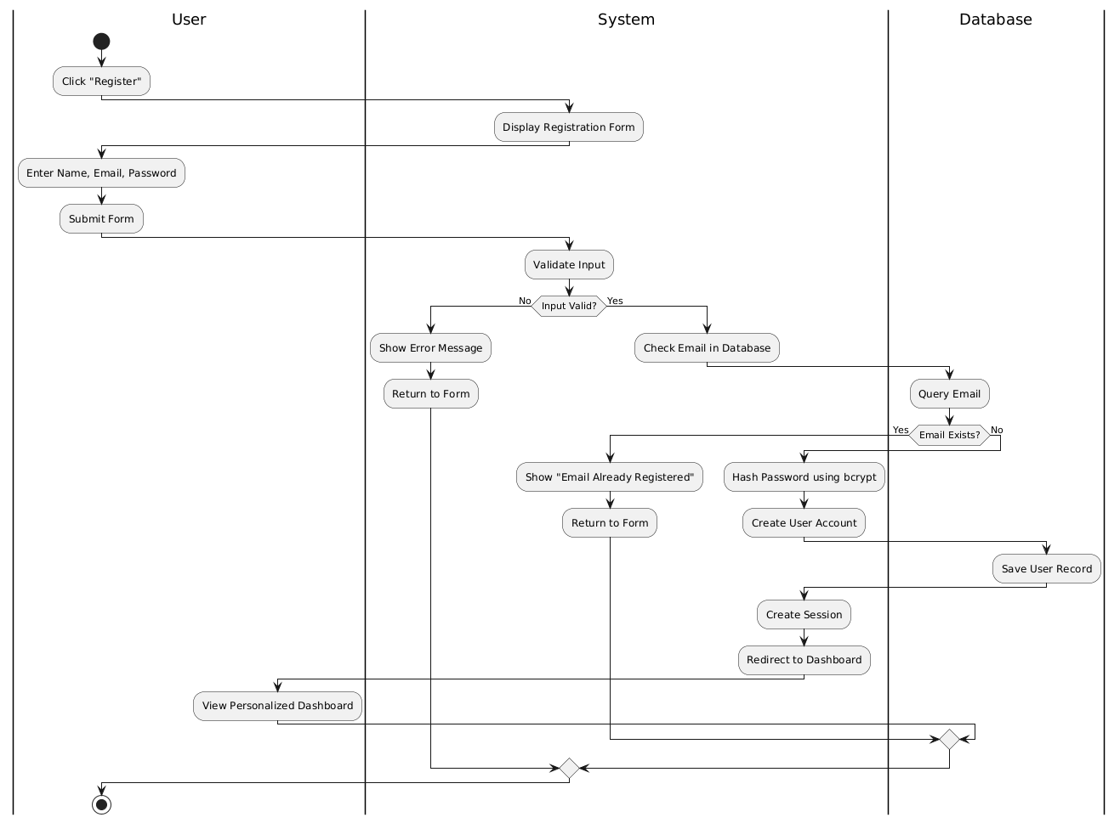

Description of Registration Flow
- Initiation: Guest clicks "Register" on the homepage or login page.
- Form Display: System shows a registration form with fields for:
  - Full name
  - Email address
  - Password
  - Confirm password
- Data Entry: Guest enters their information and submits the form.
- Validation: System checks:
  - All fields are filled
  - Email format is valid
  - Password meets minimum requirements
  - Passwords match
- Email Check: System verifies the email is not already registered.
- Account Creation: System:
  - Hashes the password using bcrypt
  - Creates a new user record in the database
  - Sets account status to "active"
- Authentication: System:
  - Generates a JWT token
  - Creates a session
  - Sets session cookies
- Redirection: User is automatically logged in and redirected to their personalized dashboard.
- Welcome: System displays a welcome message for the new user.

3.2.2 Login Activity Diagram
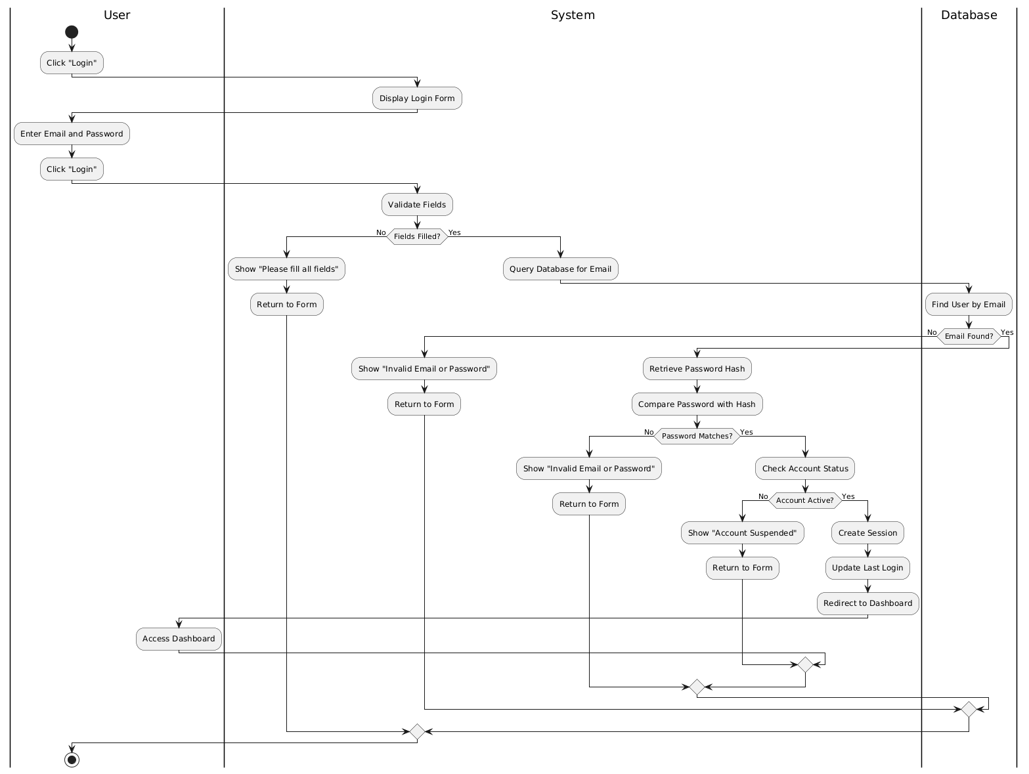
Figure 3.2 User Login Activity Diagram
Description of Login Flow:
- User: Navigates to login page and clicks "Login".
- System: Displays login form with email and password fields.
- User: Enters email and password and clicks "Login".
- System: Validates that fields are not empty.
Decision - Fields filled?
  - If No: System displays "Please fill all fields" and returns to form.
  - If Yes: System queries database for email.
- System: Looks up email in database.
Decision - Email found?
  - If No: System displays "Invalid email or password".
  - If Yes: System retrieves stored password hash.
- System: Compares entered password with stored hash using bcrypt.
Decision - Password matches?
  - If No: System displays "Invalid email or password".
  - If Yes: System checks account status.
- System: Checks if account is active.
Decision - Account active?
  - If No: System displays "Account suspended. Contact administrator."
  - If Yes: System creates session.
- System: Updates last_login timestamp.
- System: Redirects to user dashboard.
- User: Accesses personalized dashboard.

3.2.3User Logout Activity Diagram
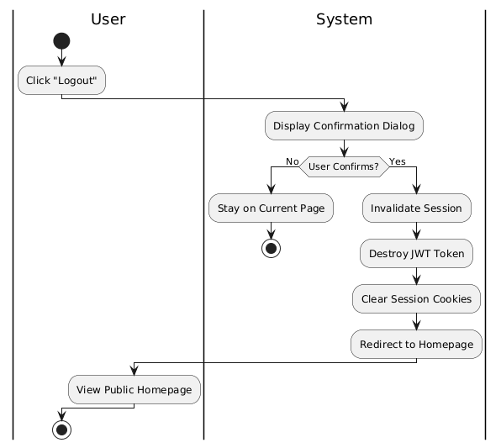
Figure 3.3 User Logout Activity Diagram
Description of Logout Flow:
- Initiation: Authenticated user clicks "Logout" in the navigation menu.
- Confirmation: System asks "Are you sure you want to logout?"
- User Confirms: User clicks "Yes" or "Confirm".
- Session Termination: System:
  - Invalidates the JWT token
  - Destroys the server-side session
  - Clears session cookies from the browser
- Redirection: User is redirected to the public homepage.
- Confirmation: System displays "You have been successfully logged out."
3.2.4 Rate Item Activity Diagram
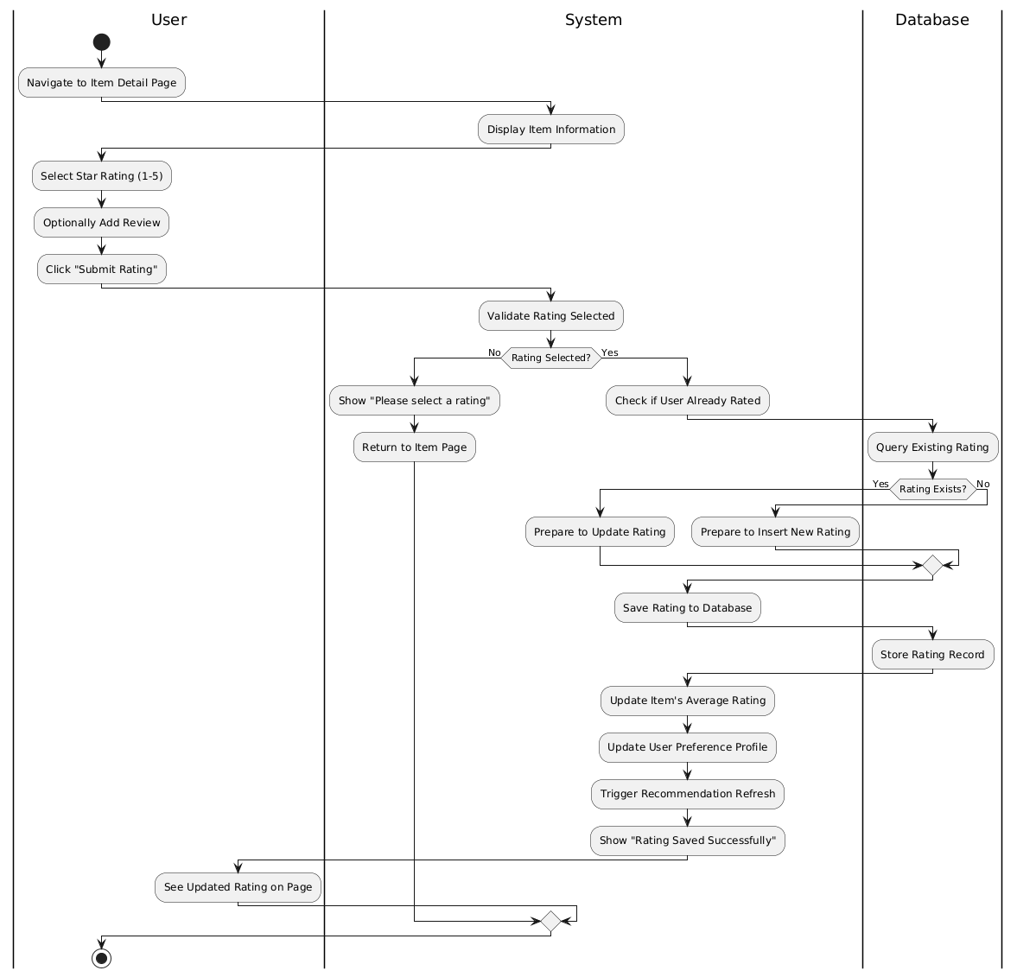
Figure 3.4 Rate Item Activity Diagram
Description of Rating Flow:
- User: Navigates to item detail page.
- System: Displays item information and current user rating (if any).
- User: Selects star rating (1-5).
- User: Optionally adds text review.
- User: Clicks "Submit Rating".
- System: Validates that a rating was selected.
Decision - Rating selected?
  - If No: System displays "Please select a rating".
  - If Yes: System checks if user already rated this item.
- System: Queries database for existing rating.
Decision - Rating exists?
  - If Yes: System prepares to update existing rating.
  - If No: System prepares to insert new rating.
- System: Saves rating to database (insert or update).
- System: Updates item's average rating.
- System: Updates user's preference profile.
- System: Triggers asynchronous recommendation refresh.
- System: Displays "Rating saved successfully" confirmation.
- User: Sees updated rating on item page.
3.4.4 Get Recommendations Activity Diagram
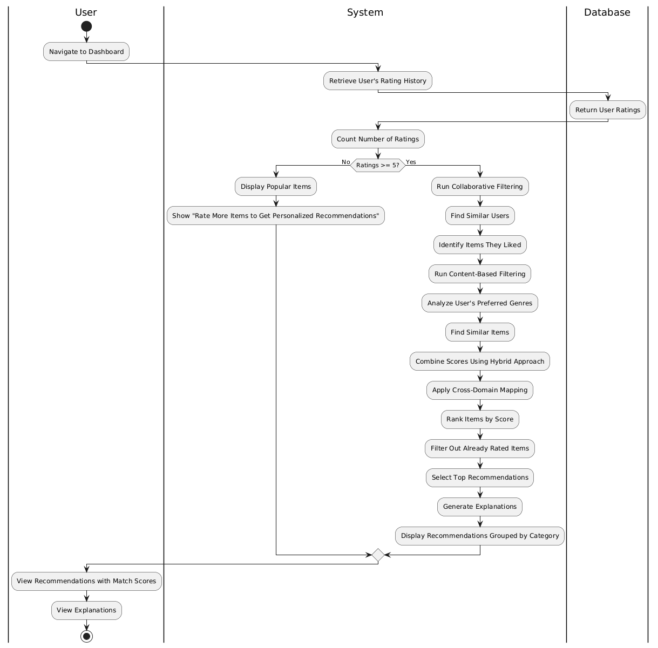
Figure 3.5 Get Recommendations Activity Diagram

Description of Recommendation Generation Flow:
- User: Navigates to dashboard or recommendations page.
- System: Retrieves user's rating history from database.
- System: Counts number of items user has rated.
Decision - Sufficient ratings (≥5)?
  - If No: System displays popular items with message "Rate more items to get personalized recommendations!"
  - If Yes: System proceeds with AI algorithms.
- System: Runs collaborative filtering algorithm.
  - Finds users with similar rating patterns.
  - Identifies items those users liked.
- System: Runs content-based filtering algorithm.
  - Analyzes genres from user's highly-rated items.
  - Finds items with similar characteristics.
- System: Combines scores using hybrid approach.
- System: Applies cross-domain mapping.
- System: Ranks items by final score.
- System: Filters out items user has already rated.
- System: Selects top recommendations for each category.
- System: Generates explanations for each recommendation.
- System: Displays recommendations grouped by category.
- User: Views personalized recommendations with match scores and explanations.
3.4.5 Search Content Activity Diagram

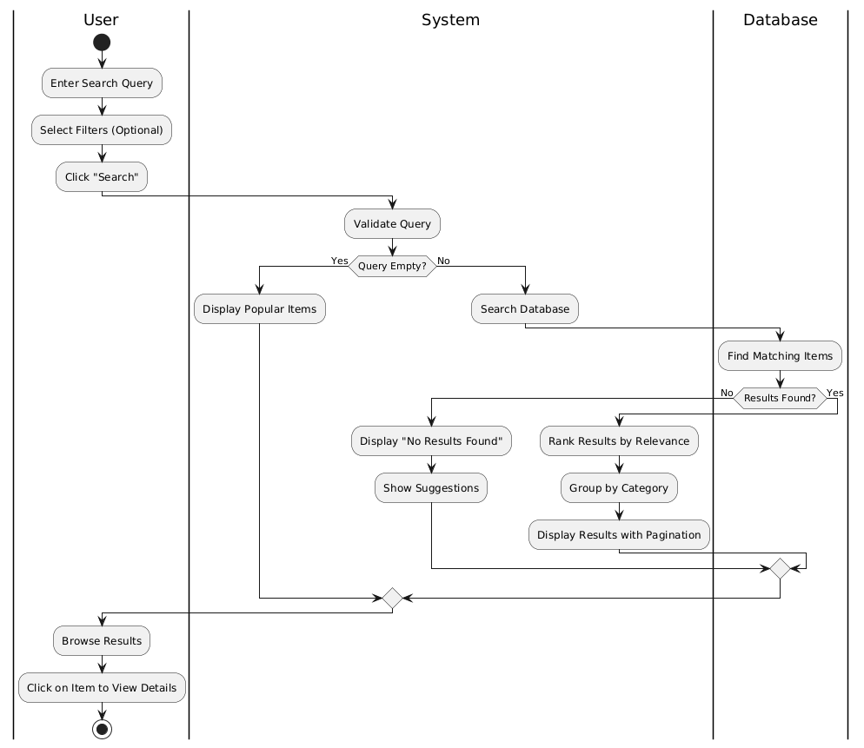
Figure 3.6 Search Content Activity Diagram

Description of Search Flow:
- User: Enters search query in search box.
- User: Optionally selects filters (category, genre, language).
- User: Clicks "Search" button or presses Enter.
- System: Validates that search query is not empty.
Decision - Query empty?
  - If Yes: System displays popular items or recent items.
  - If No: System searches database.
- System: Searches for matches in title, author/artist, description.
- System: Applies selected filters.
- System: Ranks results by relevance.
- System: Groups results by category (Books, Movies, Music).
- System: Displays results with pagination.
- User: Browses search results.
- User: Clicks on any result to view details.
Decision - Results found?
- If No results: System displays "No results found" and suggestions.

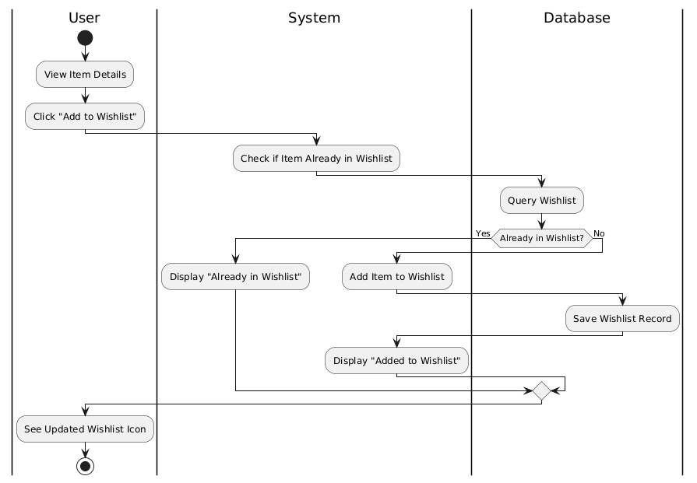
Figure 3.7 Add to Wishlist
Description of Add to Wishlist Flow
- View Item Details:
  - User: Navigates to an item detail page after browsing or searching for content they find interesting.
  - System Response: Displays complete item information including title, description, cover image, average ratings, and community reviews.
- Initiate Wishlist Addition:
  - User: Clicks the "Add to Wishlist" button, indicating they want to save this item for future reference.
  - System Response: Receives the request and begins processing by identifying the current user from the active session.
- Database Verification (Already in Wishlist Check):
  - System Action: Queries the wishlist database to verify if this specific item already exists in the user's wishlist.
  - Database: Returns the result of the query indicating whether a record exists for this user-item combination.
Decision - Already in Wishlist?
  - If Yes: The system proceeds to the "Already in Wishlist" display flow.
  - If No: The system proceeds to add the item to the wishlist.
- Already in Wishlist Flow:
  - System: Displays a message "Already in Wishlist" to inform the user that this item has been previously saved.
  - Visual Feedback: The wishlist icon appears filled or highlighted to indicate existing status.
  - End: The process terminates with the user informed of the existing wishlist status.
- Add Item to Wishlist Flow:
  - System: Creates a new wishlist record with the following data: user ID, item ID, current timestamp, and default priority.
  - Database: Saves the wishlist record permanently, establishing a relationship between the user and the saved item.
- Confirmation and Feedback:
  - System: Displays a confirmation message "Added to Wishlist" to provide immediate feedback.
  - System: Updates the visual indicator (wishlist icon) on the item page to reflect that the item is now saved.
  - User: Sees the updated wishlist icon and confirmation message.
- Session Continuation:
  - User: Can continue browsing, return to search results, or navigate to their wishlist to view all saved items.
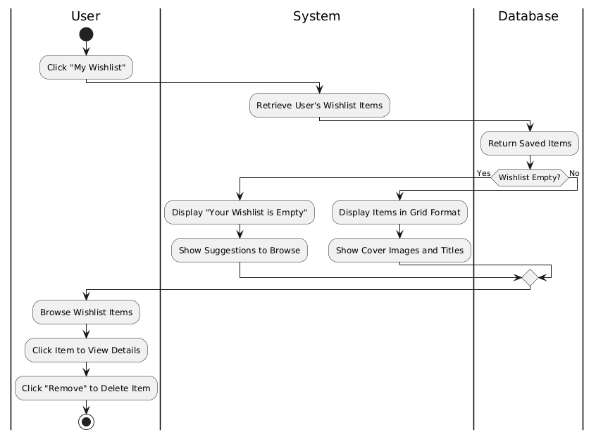
Figure 3.18 View Wishlist
Description of View Wishlist Flow
- Initiation:
  - User: Clicks on "My Wishlist" navigation link from the main menu, dashboard, or profile section.
  - System Response: Receives the request and begins processing by identifying the current user from the active session.
- Data Retrieval:
  - System: Queries the database to retrieve all wishlist items associated with the user's ID.
  - System: Joins with the Items table to get complete item details including titles, cover images, authors/artists, and metadata.
  - Database: Returns all saved items for the user.
- Wishlist Status Check:
  - System: Evaluates whether any items were returned from the database query.
Decision - Wishlist Empty?
  - If Yes: Proceeds to empty wishlist flow.
  - If No: Proceeds to display items flow.
- Empty Wishlist Flow:
  - System: Displays a friendly message "Your Wishlist is Empty".
  - System: Shows suggestions for content to browse, such as popular items, recommended categories, or a "Browse Content" button.
  - User: Can click on suggestions to discover new content.
  - End: User engages with suggested content or returns to other sections.
- Display Items Flow:
  - System: Formats and displays the wishlist items in an organized grid format.
  - Visual Presentation: Each item shows cover image, title, and brief metadata.
  - User: Browses through their saved items collection.
- Item Interaction Options:
Option A - View Item Details:
  - User: Clicks on any wishlist item to view its complete details.
  - System: Navigates to the item detail page for the selected item.
  - User: Views complete information and can take further actions (rate, review, etc.).
  - User: Can return to wishlist using back navigation.
Option B - Remove Item:
  - User: Clicks "Remove" button on a wishlist item.
  - System: Displays confirmation dialog "Are you sure you want to remove this item?"
  - User: Confirms removal.
  - System: Sends delete request to database.
  - Database: Permanently deletes the wishlist record.
  - System: Refreshes the wishlist display showing updated collection.
  - System: Displays confirmation "Item removed from wishlist".
- Session Continuation:
  - User: Continues managing wishlist or navigates to other sections.
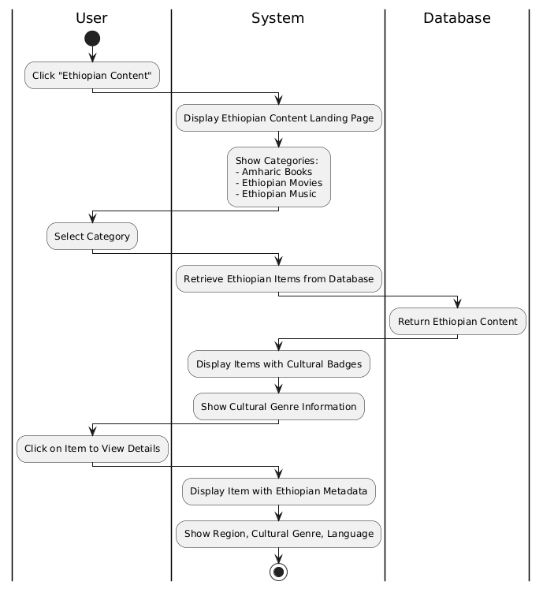
Figure 3.19 Ethiopian Conten
Description of Ethiopian Content Viewing Flow
- Initiation:
  - User: Clicks on "Ethiopian Content" from the main navigation menu or homepage featured section.
  - System Response: Recognizes the user's interest in culturally-specific content and begins processing.
- Landing Page Display:
  - System: Displays the Ethiopian Content Landing Page with a culturally-inspired design.
  - Content Organization: Page shows three main categories prominently:
    - Amharic Books (with sample covers and authors)
    - Ethiopian Movies (with film posters and directors)
    - Ethiopian Music (with artist images and album art)
  - Cultural Elements: The page may include traditional patterns or colors to create cultural resonance.
- Category Selection:
  - User: Selects a specific category of interest (Amharic Books, Ethiopian Movies, or Ethiopian Music).
  - System: Records the category selection and prepares to retrieve relevant content.
- Database Query:
  - System: Queries the database for items matching the selected category with Ethiopian content flag.
  - System: Applies any additional filters based on Ethiopian metadata (traditional genres, regions, etc.).
  - Database: Returns all Ethiopian content items matching the criteria.
- Content Return:
  - Database: Successfully returns Ethiopian content items with their complete metadata.
  - System: Receives the data and prepares for display.
- Content Display with Cultural Badges:
  - System: Displays Ethiopian content items in an attractive grid or list format.
  - Cultural Badges: Each item shows special indicators:
    - "Amharic" badge for language
    - Traditional genre badge (e.g., "Tizita", "Bati", "Anchihoye" for music)
    - Region of origin badge (e.g., "Gondar", "Addis Ababa")
  - Cultural Genre Information: Additional metadata shows traditional classifications.
- Item Selection:
  - User: Clicks on a specific Ethiopian content item to view details.
  - System: Retrieves complete item information including Ethiopian-specific metadata.
- Enhanced Detail Display:
  - System: Displays item detail page with Ethiopian cultural information prominently shown:
    - Amharic title alongside English title (if available)
    - Region of origin
    - Cultural genre classification
    - Traditional instruments (for music)
    - Cultural significance description
    - Related Ethiopian content suggestions
  - User: Views complete culturally-enriched information.
- Further Engagement:
  - User: Can rate the item, add to wishlist, or explore more Ethiopian content.
  - System: Records user engagement to improve future Ethiopian content recommendations.

3.4.6 Admin Add Content Activity Diagram

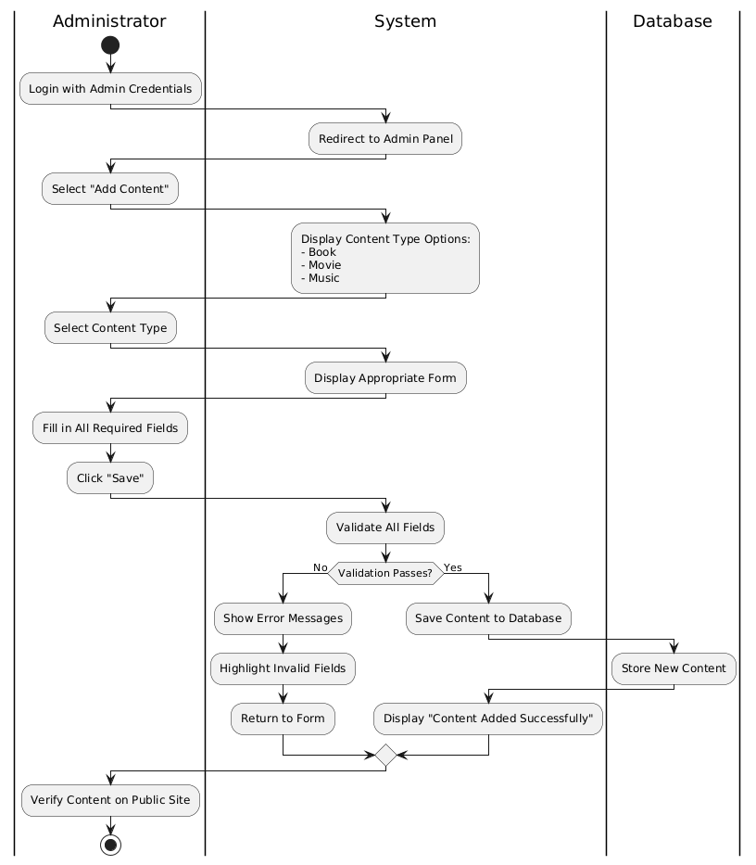
Figure 3.7 Admin Add Content Activity Diagram
Description of Admin Add Content Flow:
- Admin: Logs in with admin credentials.
- System: Redirects to Admin Panel.
- Admin: Selects "Add Content" from menu.
- System: Displays content type options (Book, Movie, Music).
- Admin: Selects content type.
- System: Shows appropriate form for selected type.
- Admin: Fills in all required fields.
- Admin: Clicks "Save" button.
- System: Validates all required fields.
Decision - Validation passes?
  - If No: System displays error messages and highlights invalid fields.
  - If Yes: System saves content to database.
- System: Displays "Content added successfully" confirmation.
- Admin: Can verify by viewing content on public site.

3.4.7 Admin Manage Users Activity Diagram

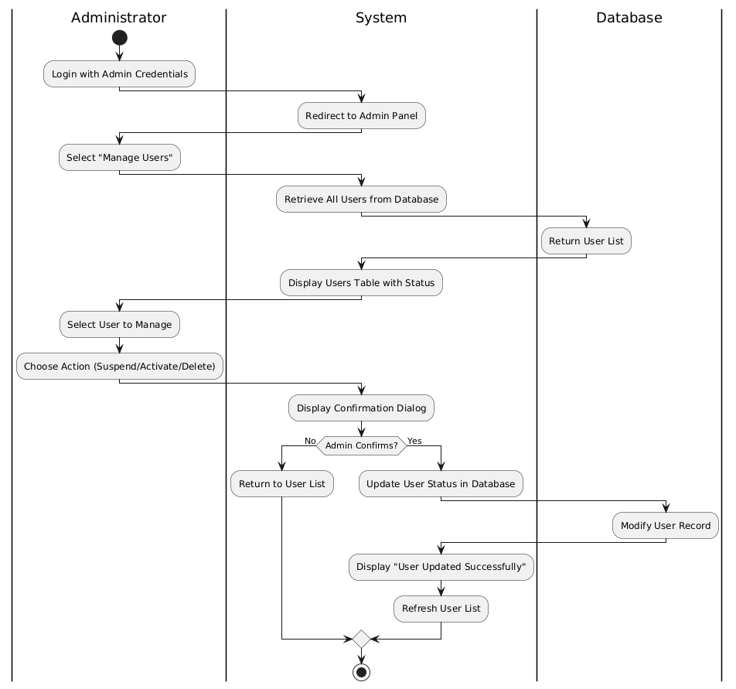
Figure 3.8 Admin Manage Users Activity Diagram
Description of Admin Manage Users Flow:
- Admin: Logs in with admin credentials.
- System: Redirects to Admin Panel.
- Admin: Selects "Manage Users" from menu.
- System: Displays list of all users with status.
- Admin: Selects a user to manage.
- Admin: Chooses action (Suspend, Activate, Delete).
- System: Displays confirmation dialog.
Decision - Admin confirms?
  - If No: System returns to user list without changes.
  - If Yes: System updates user status in database.
- System: Displays "User updated successfully" confirmation.
- System: Refreshes user list with updated status.
3.3 DATA DICTIONARY
A data dictionary is simply a list of all the information we store, with notes about what kind of data it is and what rules apply to it. Think of it as a detailed table of contents for our database.
3.10 User Table
Field Name | Data Type | Length | Null | Description
User _id | INT | 11 | NOT NULL | Primary key, auto-increment
name | VARCHAR | 100 | NOT NULL | User's full name
email | VARCHAR | 100 | NOT NULL | User's email (unique)
Password _hash | VARCHAR | 255 | NOT NULL | Bcrypt hashed password
Created _at | DATETIME | - | NOT NULL | Account creation timestamp
last_ login | DATETIME | - | NULL | Last login timestamp
status | ENUM | - | NOT NULL | active/inactive/suspended/deleted
preferences | TEXT | - | NULL | JSON of user preferences
avatar | VARCHAR | 255 | NULL | Profile picture path
Table 3.1 User
3.11 Item Table
Field Name | Data Type | Length | Null | Description
item_ id | INT | 11 | NOT NULL | Primary key, auto-increment
Title | VARCHAR | 255 | NOT NULL | Item title
Type | ENUM | - | NOT NULL | 'book', 'movie', 'music'
Description | TEXT | - | NULL | Item description
Release year | INT | 4 | NULL | Year of release
Language | VARCHAR | 50 | NULL | Language
Country | VARCHAR | 50 | NULL | Country of origin
Cover image | VARCHAR | 255 | NULL | Image filename/path
Created at | DATETIME | - | NOT NULL | Record creation timestamp
Updated at | DATETIME | - | NULL | Last update timestamp
Status | ENUM | - | NOT NULL | active/archived
Table 3.2 Item

3.13 Book-Specific Attributes Table
Field Name | Data Type | Length | Null | Description
Book _id | INT | 11 | NOT NULL | Primary key, references item.item_id
Author | VARCHAR | 255 | NOT NULL | Author name(s)
Isbn | VARCHAR | 20 | NULL | International Standard Book Number
Pages | INT | - | NULL | Number of pages
Publisher | VARCHAR | 100 | NULL | Publisher name
Genre | VARCHAR | 100 | NULL | Book genre/category
Table 3.3 Book-Specific Attributes
3.14 Movie-Specific Attributes Table
Field Name | Data Type | Length | Null | Description
movie_ id | INT | 11 | NOT NULL | Primary key, references item.item_id
Director | VARCHAR | 255 | NULL | Director name(s)
Duration | INT | - | NULL | Duration in minutes
Cast | TEXT | - | NULL | Main cast members
Rating | VARCHAR | 10 | NULL | Content rating (PG, R, etc.)
Genre | VARCHAR | 100 | NULL | Movie genre/category
Table 3.4 Movie-Specific Attributes
3.15 Music-Specific Attributes Table
Field Name | Data Type | Length | Null | Description
music_ id | INT | 11 | NOT NULL | Primary key, references item.item_id
Artist | VARCHAR | 255 | NOT NULL | Artist/band name
Album | VARCHAR | 255 | NULL | Album name
Duration | INT | - | NULL | Duration in seconds
Genre | VARCHAR | 100 | NULL | Music genre/category
Track _number | INT | - | NULL | Track number if album
Table 3.5 Music-Specific Attributes
3.16 Rating Table
Field Name | Data Type | Length | Null | Description
rating_ id | INT | 11 | NOT NULL | Primary key, auto-increment
User _id | INT | 11 | NOT NULL | Foreign key to User
Item _id | INT | 11 | NOT NULL | Foreign key to Item
Score | TINYINT | 1 | NOT NULL | Rating 1-5
Review | TEXT | - | NULL | Optional text review
Timestamp | DATETIME | - | NOT NULL | Rating timestamp
Updated _at | DATETIME | - | NULL | Last update timestamp
Table 3.6 Rating Table
3.17 Preference Table
Field Name | Data Type | Length | Null | Description
Pref _id | INT | 11 | NOT NULL | Primary key, auto-increment
User _id | INT | 11 | NOT NULL | Foreign key to User
Category | ENUM | - | NOT NULL | 'book', 'movie', 'music'
Genre | VARCHAR | 100 | NOT NULL | Preferred genre
Weight | FLOAT | - | NOT NULL | Preference strength (0-1)
Updated _at | DATETIME | - | NOT NULL | Last update
Table 3.7 Preference
3.18 Recommendation Table
Field Name | Data Type | Length | Null | Description
Rec _id | INT | 11 | NOT NULL | Primary key, auto-increment
User _id | INT | 11 | NOT NULL | Foreign key to User
Item _id | INT | 11 | NOT NULL | Foreign key to Item
score | FLOAT | - | NOT NULL | Recommendation score
rank | INT | - | NOT NULL | Display rank
Generated _at | DATETIME | - | NOT NULL | Generation timestamp
algorithm | VARCHAR | 50 | NOT NULL | Algorithm used (collab/content/hybrid)
Expires _at | DATETIME | - | NOT NULL | When recommendation expires
Table 3.8 Recommendation
Field Name | Data Type | Length | Null | Description
wishlist_id | INT | 11 | NOT NULL | Primary key, auto-increment
user_id | INT | 11 | NOT NULL | Foreign key to User table
item_id | INT | 11 | NOT NULL | Foreign key to Item table
added_date | DATETIME | - | NOT NULL | When item was added to wishlist
priority | ENUM | - | NULL | 'High', 'Medium', 'Low' (for future consumption priority)
notes | VARCHAR | 255 | NULL | User's personal notes about why they want this
notification_enabled | BOOLEAN | - | DEFAULT FALSE | Whether user wants notifications about this item
Table 3.9: Wishlist Table
Field Name | Data Type | Length | Null | Description
ethiopian_id | INT | 11 | NOT NULL | Primary key, auto-increment
item_id | INT | 11 | NOT NULL | Foreign key to Item table
cultural_region | VARCHAR | 100 | NULL | Region of origin (e.g., 'Gondar', 'Addis Ababa', 'Tigray', 'Oromia')
traditional_genre | VARCHAR | 100 | NULL | Ethiopian-specific genre
is_traditional | BOOLEAN | - | DEFAULT FALSE | Whether this is traditional/cultural content
has_amharic_title | BOOLEAN | - | DEFAULT FALSE | Whether Amharic title is available
amharic_title | VARCHAR | 255 | NULL | Title in Amharic script (if applicable)
amharic_description | TEXT | - | NULL | Description in Amharic (if applicable)
cultural_significance | TEXT | - | NULL | Explanation of cultural importance
featured_priority | INT | 2 | DEFAULT 0 | Priority for featured section (0-10, higher = more prominent)
curated_by | VARCHAR | 100 | NULL | Who added/curated this content
curation_date | DATETIME | - | NOT NULL | When content was curated
Table 3.10: Ethiopian Content Metadata Table
Class model
The class model describes the structural design of the system by identifying the main classes, their attributes, methods, and the relationships between them. It provides a clear understanding of how the system is logically organized before implementation. In the Personal Movie, Music, and Book Recommendation System, the class model is designed to represent real-world entities such as users, content, ratings, and recommendations. Each class plays a specific role in ensuring that the system functions properly and delivers personalized recommendations.

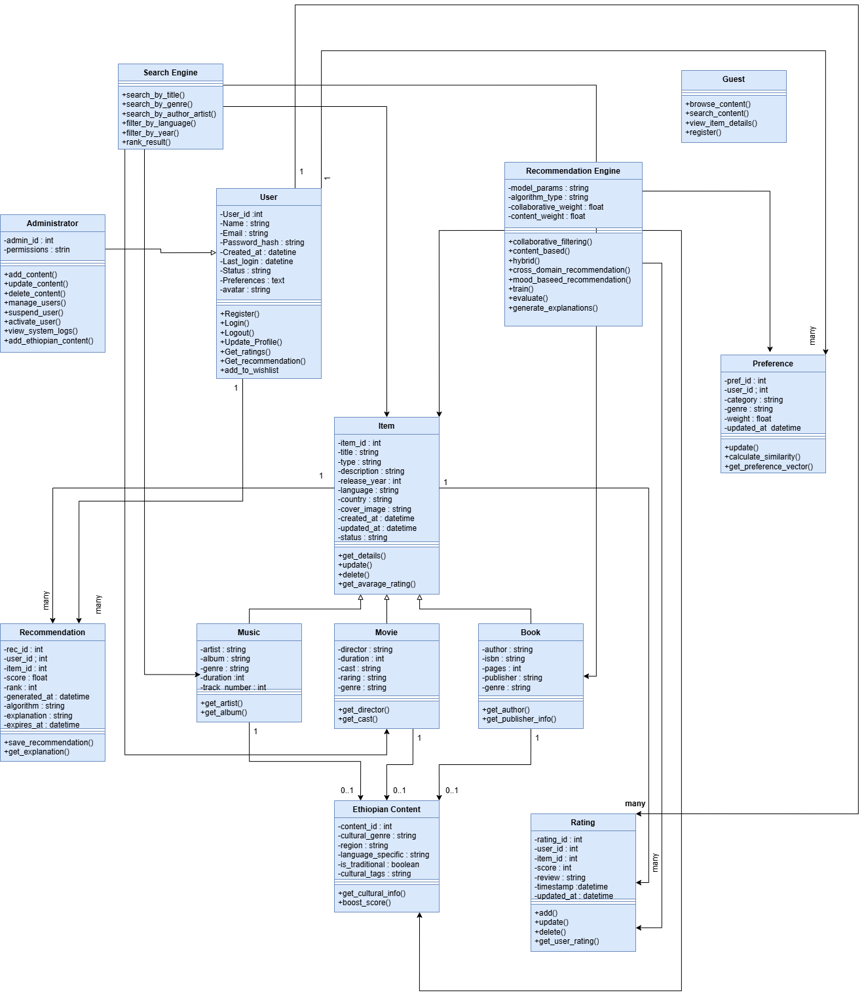

Figure 3-9 Class Model Diagram
Dynamic Modeling
Dynamic modeling describes how the system behaves over time. While the class model explains the structure of the system, dynamic modeling focuses on interactions, activities, and the flow of operations between different components of the system.
In the Personal Movie, Music, and Book Recommendation System, dynamic modeling explains how users interact with the system, how data flows from one component to another, and how recommendations are generated. Dynamic modeling is mainly represented using sequence descriptions, activity flows, and state changes.
3.4 State Chart Diagram
The State Chart Diagram describes how objects in the system change from one state to another based on different events. It shows the behavior of the system over time and explains how the system responds to user and admin actions.
In the Personal Movie, Music, and Book Recommendation System, the state chart mainly focuses on the User account and Content objects because they are the core components of the system.
1. User Account State
The User account passes through several states during its lifecycle in the system.
Initial State
The process starts when a person visits the system but has not yet registered. At this point, the user is in the New state.
Registered State
After the user fills in the registration form and the system successfully saves the information in the database, the state changes to Registered. The user now has an account in the system.
Logged-In State
When the registered user enters the correct email and password, the system verifies the credentials and changes the state to Logged-In. In this state, the user can:
- Search for movies, music, and books
- Rate content
- Receive recommendations
- Update profile
Logged-Out State
When the user clicks the logout button, the system moves the account to the Logged-Out state. The user must log in again to access the system features.
Deactivated State
If the administrator removes or blocks the account, the state changes to Deactivated, and the user cannot access the system anymore.
2. Content State
Content items such as movies, music, and books also have their own states.
New State
When the admin adds new content to the system, it enters the New state.
Available State
After validation and successful storage in the database, the content becomes Available. Users can now view and rate it.
Updated State
If the admin edits or modifies the content details, the state changes to Updated.
Deleted State
If the admin removes the content from the system, it moves to the Deleted state and becomes unavailable to users.
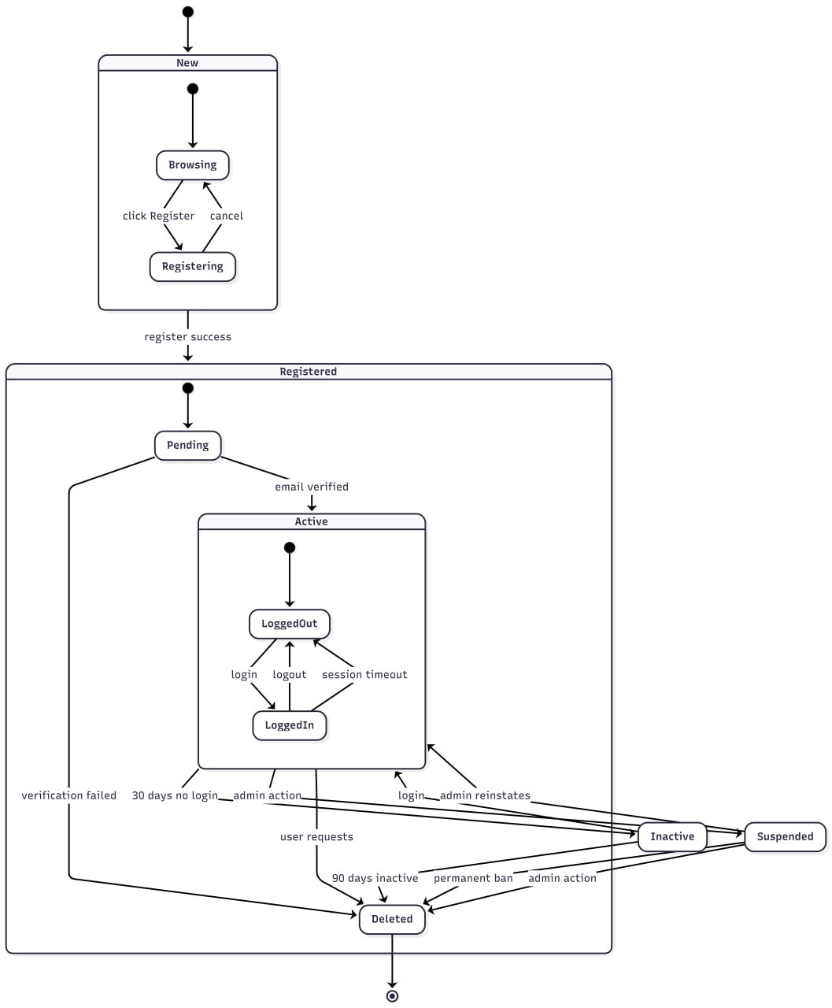
Figure 3.10 State Chart Diagram
3.5 Sequence Diagram
The Sequence Diagram describes how different components of the system interact with each other in a particular order to complete a task. It focuses on the flow of messages between objects over time.
In the Personal Movie, Music, and Book Recommendation System, the sequence diagram explains how users, the system, and the database communicate during major processes such as registration, login, rating, and recommendation generation.

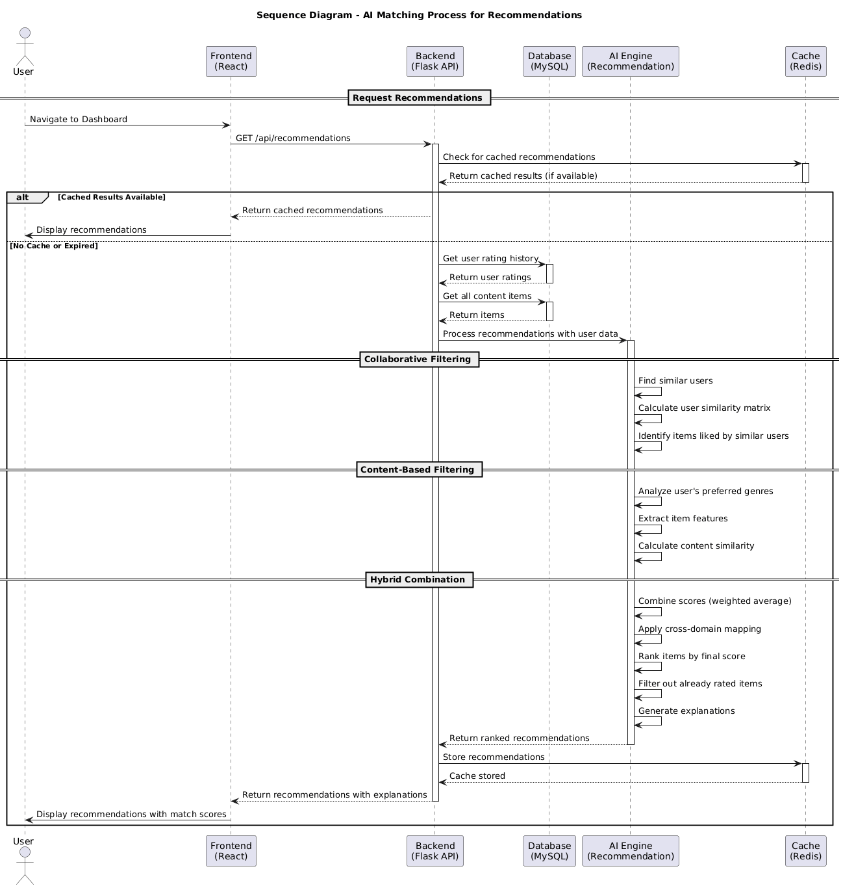\
Figure 3.11 Sequence Diagram for AI Matching Flow
Description of AI Matching Flow:
- Request and Data Retrieval:
  - User: Navigates to the dashboard to request recommendations.
  - Frontend: Sends a GET request to the backend API.
  - Backend: Checks Redis cache for existing recommendations.
If cached results exist: Returns immediately to the user.
If no cache or expired: Proceeds to fetch data from database.
- Data Collection:
  - Backend: Queries MySQL database for user's rating history.
  - Database: Returns all items the user has rated.
  - Backend: Queries for all available content items (books, movies, music).
  - Database: Returns complete item catalog.
- AI Processing (The Core Logic):
  - AI Engine: Receives user ratings and all items.
  - Collaborative Filtering: Finds users with similar tastes and identifies items they liked.
  - Content-Based Filtering: Analyzes genres and features from user's highly-rated items.
  - Hybrid Scoring: Combines both approaches with weighted scores.
  - Ranking: Sorts items by final score and filters out already rated items.
  - Explanations: Generates reasons for each recommendation.
- Response and Display:
  - AI Engine: Returns ranked recommendations to backend.
  - Backend: Stores recommendations in Redis cache for future requests.
  - Backend: Sends recommendations to frontend.
  - Frontend: Displays personalized recommendations with match scores and explanations.
  - User: Views curated list of suggested books, movies, and music.
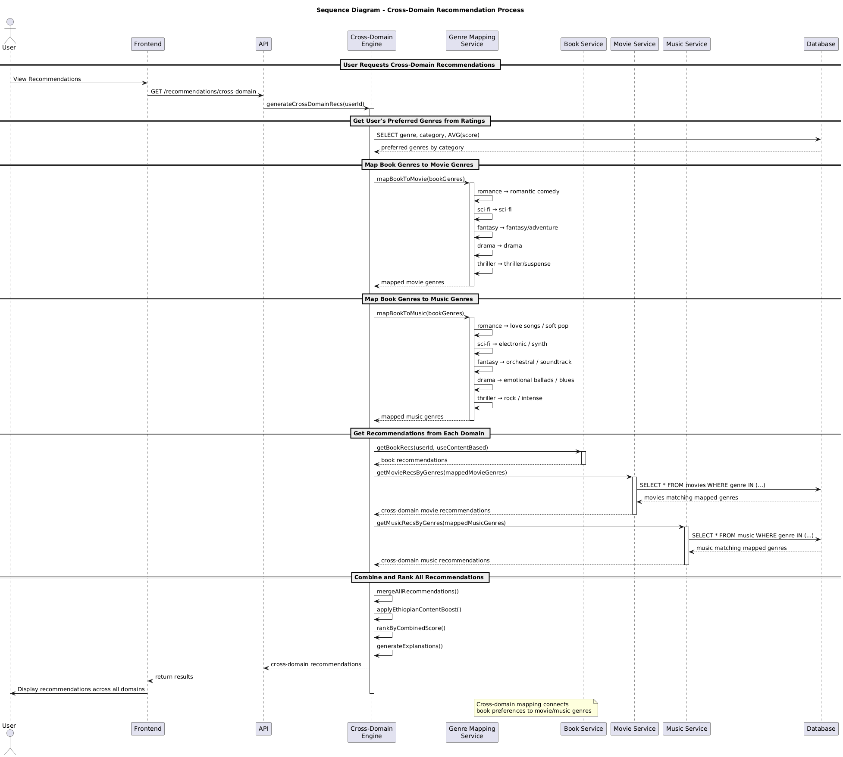
Figure 3.12 Sequence Diagram for Cross-Domain Recommendation Flow
Description of Cross-Domain Recommendation Flow:
- Request Initiation:
  - User: Navigates to view recommendations.
  - Frontend: Sends GET request to /recommendations/cross-domain.
  - API: Calls generate Cross Domain Recs(user Id) to start the process.
- Get User's Preferred Genres:
  - API: Queries database for user's rating history.
  - Database: Returns preferred genres by category with average scores.
  - Example: User loves Romance and Drama books.
- Map Book Genres to Movie Genres:
  - API: Calls map Book To Movie(book Genres) function.
  - Mapping Logic:
    - Romance → Romantic Comedy
    - Sci-Fi → Sci-Fi
    - Fantasy → Fantasy/Adventure
    - Drama → Drama
    - Thriller → Thriller/Suspense
  - Result: Returns mapped movie genres based on user's book preferences.
- Map Book Genres to Music Genres:
  - API: Calls map Book To Music(book Genres) function.
  - Mapping Logic:
    - Romance → Love Songs / Soft Pop
    - Sci-Fi → Electronic / Synth
    - Fantasy → Orchestral / Soundtrack
    - Drama → Emotional Ballads / Blues
    - Thriller → Rock / Intense
  - Result: Returns mapped music genres based on user's book preferences.
- Get Recommendations from Each Domain:
  - Book Service: Fetches book recommendations using content-based filtering.
  - Movie Service: Queries database for movies matching mapped genres.
  - Music Service: Queries database for music matching mapped genres.
  - Database: Returns items matching the genre criteria.
- Combine and Rank All Recommendations:
  - API: Merges all recommendations from books, movies, and music.
  - API: Applies Ethiopian content boost if user shows interest.
  - API: Ranks items by combined relevance score.
  - API: Generates explanations for each recommendation.
- Response and Display:
  - API: Returns results to frontend.
  - Frontend: Displays cross-domain recommendations to user.
  - User: Sees movies and music suggestions based on their book preferences.

Example Scenario:
If a user has rated several romance novels highly:
- The system maps Romance → Romantic Comedy movies
- The system maps Romance → Love Songs music
- The user receives movie recommendations like "The Notebook"
- The user receives music recommendations like love ballads
- Each recommendation includes an explanation: "Based on your love of Romance books"
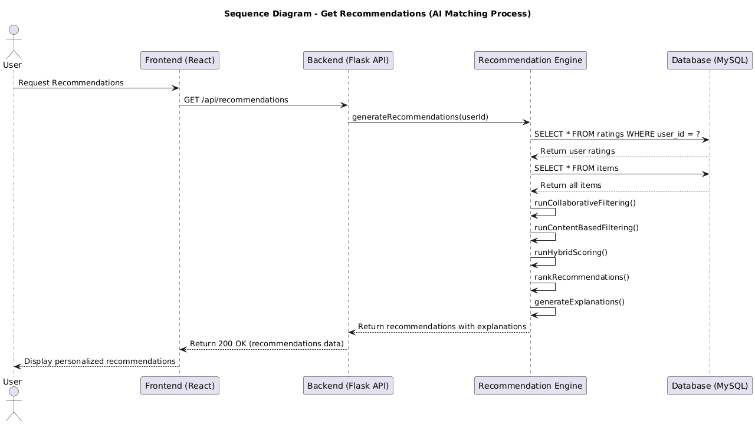
Figure 3.13 Sequence Diagram for Get Recommendations Flow
Description of Get Recommendations Flow:
- Request Initiation:
  - User: Requests personalized recommendations from the system.
  - Frontend: Sends a GET request to /api/recommendations endpoint.
- Data Collection Phase:
  - Backend: Calls generate Recommendations(userId) to start the process.
  - Backend: Queries database for user's rating history.
  - Database: Returns all items the user has rated.
  - Backend: Queries database for all available content items.
  - Database: Returns complete catalog of books, movies, and music.
- AI Processing Phase (The Core Logic):
  - Recommendation Engine: Receives user ratings and all items.
  - Collaborative Filtering: Finds users with similar rating patterns and identifies items they liked that the current user hasn't seen.
  - Content-Based Filtering: Analyzes genres, authors, directors, and artists from items the user rated highly, then finds similar items.
  - Hybrid Scoring: Combines both approaches using weighted averages.
  - Ranking: Sorts items by final score and filters out already rated items.
  - Explanations: Generates human-readable reasons for each recommendation.
- Response and Display Phase:
  - Recommendation Engine: Returns ranked recommendations to backend.
  - Backend: Sends recommendations data with 200 OK status.
  - Frontend: Displays personalized recommendations grouped by category.
  - User: Views curated list with match scores and explanations.
3.6 USER INTERFACE
The User Interface (UI) design describes how the system presents content to users and facilitates interaction with the recommendation engine. The Personal Movie, Music, and Book Recommendation System utilizes a responsive web-based interface built with HTML5, CSS3, JavaScript, and React.js. The design philosophy prioritizes warmth, intuitive discovery, and seamless browsing across all three content domains—with special attention to showcasing Ethiopian content alongside international favorites.
Home Page (Guest View)
This is what visitors see before logging in. The page shows a clear header explaining the platform's value, a "Popular This Week" section, featured Ethiopian content with Amharic titles, sign up buttons, and a short quote from a beta user to build trust.
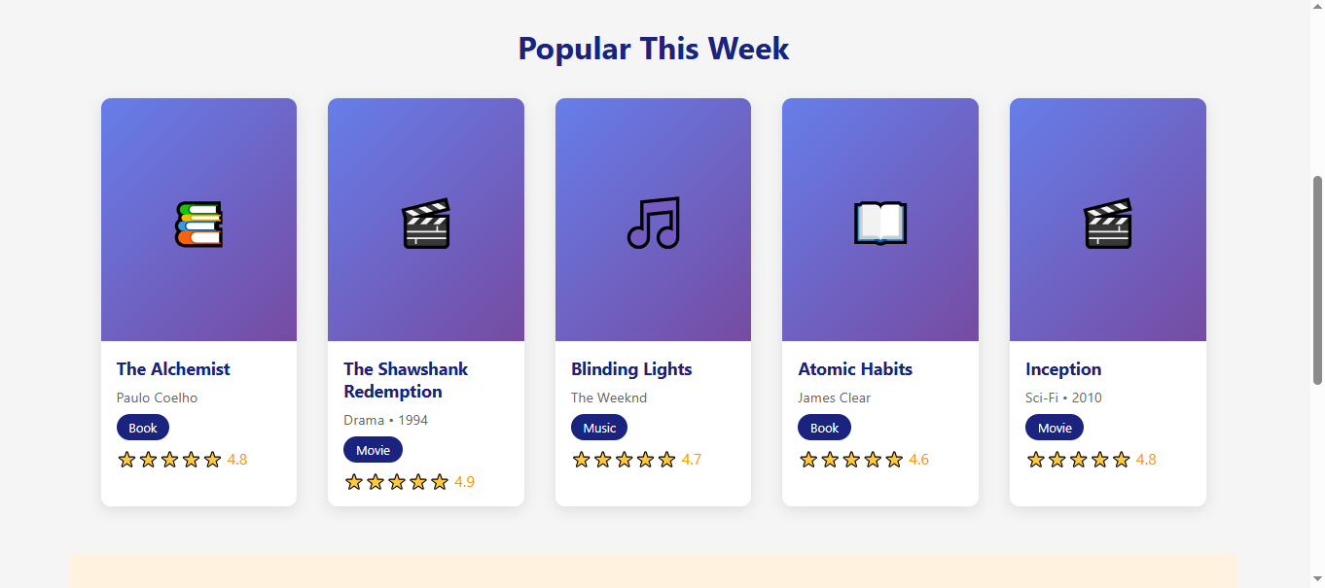
Figure 3-14 Home Page
User Dashboard (Logged In)
This is the personalized home base for registered users. The dashboard shows a warm welcome with the user's name, a recommendation header explaining that suggestions are based on their preferences and history, and clearly labeled sections for books, movies, and music. Content appears in clean card layouts. Ethiopian content is integrated naturally within each category, not separated but celebrated.
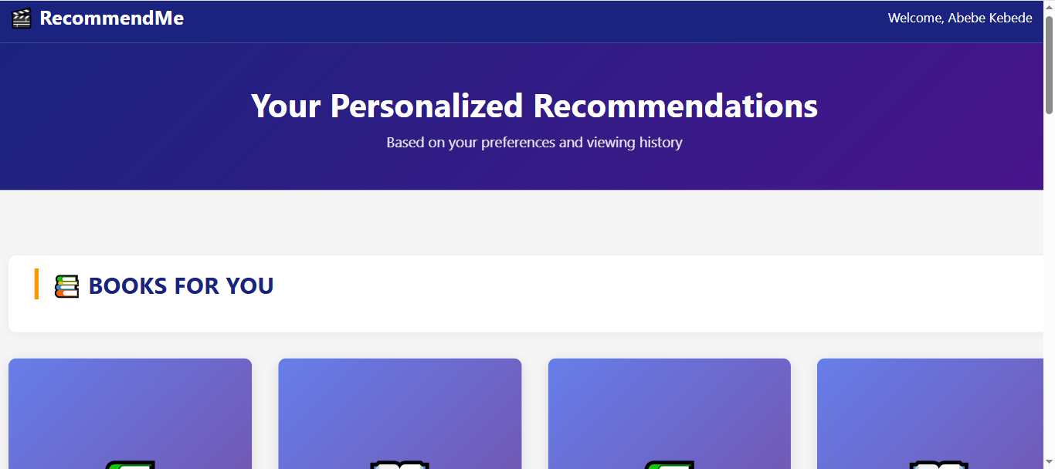
Figure 3-15 User Dashboard
Item Detail Page
The Item Detail Page provides comprehensive information about a specific book, movie, or music item. As shown in Figure 3.4, the interface features:
- Rich Media Display: Cover image prominently displayed with key metadata.
- Rating Widget: Interactive star rating system showing average community rating.
- Bilingual Support: Ethiopian content displays titles and descriptions in both Amharic and English where available.
- Community Reviews: Real user reviews with names and ratings.
- Related Recommendations: "You might also like" section with similar items.
- Action Buttons: Clear options to rate, favorite, or share items.

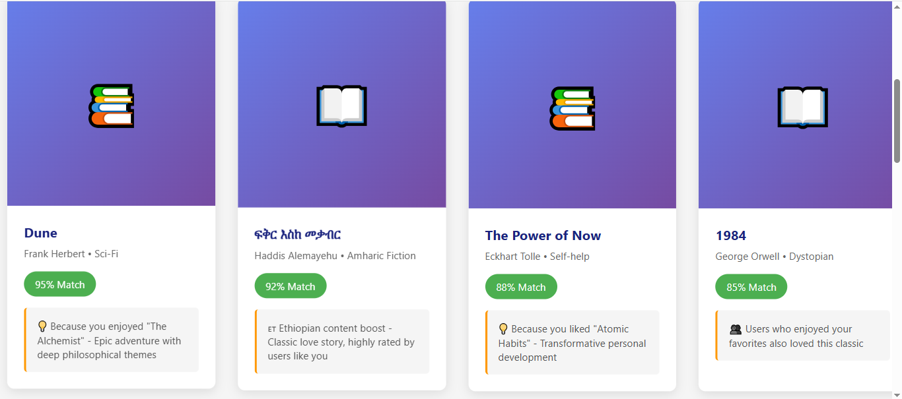
Figure 3-16 Item Detail Page

CHAPTER FOUR: SYSTEM DESIGN
4.1 Introduction
This chapter details the system design for the Personal Movie, Music, and Book Recommendation System, transitioning from the theoretical requirements and behavioral models of Chapter 3 into a concrete technical blueprint. The design phase addressed practical implementation considerations, including system scalability, component interaction, and data persistence.
The primary design goal was to ensure modularity, maintainability, and the effective integration of machine learning algorithms within a standard web framework. Guided by the advisor, the system adopts a three-tier architectural pattern to enforce separation of concerns. This chapter explicitly maps system requirements to software components, defining the presentation, application, and data layers, alongside the persistent data schema and security protocols.
4.2 Current Software Architecture
As established in the requirement analysis, there is no existing unified software architecture for cross-domain entertainment discovery with Ethiopian context. Users currently rely on a fragmented ecosystem of isolated global platforms (Netflix, Spotify, Goodreads) and informal manual channels (Telegram, word-of-mouth). Therefore, a completely new software architecture is proposed from the ground up.
4.3 Proposed Software Architecture
The proposed system employs a strict Three-Tier Architecture, which separates the application into three distinct logical and physical layers. This separation ensures that modifications in one layer do not cascadingly impact the others, enhancing maintainability and scalability.
4.3.1 Presentation Layer
This layer encompasses all user-facing components, responsible for rendering the interface and capturing user inputs. It is implemented using React.js, executing entirely within the client's browser. The presentation layer handles client-side routing, form validation, and the dynamic rendering of recommendation feeds without requiring full page reloads. It strictly communicates with the backend via RESTful API calls using JSON payloads. It enforces no business rules or database interactions.
4.3.2 Application Layer
This layer acts as the system's core processing unit, implemented using Python with the Flask framework. It exposes RESTful API endpoints consumed by the Presentation Layer. Upon receiving requests, this layer executes business logic, interacts with the Data Layer, and orchestrates the recommendation engines. To maintain modularity, the application layer is subdivided into distinct modules: User Management, Item Management, Rating Processing, and the core Recommendation Engine. Python was specifically chosen for this tier due to its robust ecosystem for data processing and machine learning (scikit-learn, Pandas).
4.3.3 Data Layer
This layer is responsible for the persistent storage and retrieval of structured data. It is implemented using MySQL, a relational database management system selected for its reliability in handling structured user profiles, item metadata, and relational rating data. The Application Layer interacts with this tier exclusively through SQLAlchemy, an Object-Relational Mapping (ORM) tool. The use of an ORM abstracts raw SQL queries into Python objects, ensuring code cleanliness and mitigating common database vulnerabilities such as SQL Injection.
4.4 System Decomposition
To manage system complexity and facilitate parallel development, the system is decomposed into four primary subsystems. Each subsystem encapsulates a specific domain of functionality.
4.4.1 User Management Subsystem
This subsystem manages user identity and access. It handles secure registration, JWT-based authentication, and session management. Furthermore, it maintains user profiles, tracking preference histories and rating behaviors. It operates largely independently, interfacing with other subsystems only to verify user identities and log rating activities.
4.4.2 Content Management Subsystem
This subsystem is responsible for the aggregation, storage, and curation of all media items. It includes dedicated parsers for fetching and normalizing data from external APIs (TMDB, Spotify, Google Books), which return disparate data formats. Crucially, it contains the Ethiopian Content Module, allowing administrators to manually input and categorize local content with appropriate cultural metadata (e.g., Tizita genre classification) that global APIs omit.
4.4.3 Recommendation Engine Subsystem
This subsystem serves as the system's core intelligence. It is subdivided into algorithmic components:
- Data Preparation: Constructs user-item rating matrices.
- Collaborative Filtering: Calculates user-to-user similarities.
- Content-Based Filtering: Calculates item-to-item similarities based on metadata.
- Hybrid Aggregator: Merges the outputs of the above algorithms, applying weightings and managing cross-domain logic.
- Explanation Generator: Produces textual justifications for recommendations (e.g., "Because you liked [Item]").
- Cold-Start Handler / Survey Seeder: When a user completes the onboarding survey, the system does not just save text; it translates the survey answers into a mathematical baseline for the algorithms:
  - For Content-Based Filtering (CBF): The selected genres (e.g., "Tizita", "Thriller Movies") are immediately mapped to the user's Preference vector with a high default weight (e.g., 0.8). When the CBF algorithm runs, it instantly matches these weighted vectors against the Item metadata vectors.
- For Collaborative Filtering (CF): The survey selections are used to find the nearest neighbor. The system clusters the new user with existing users who have those same genres highly rated, and recommends what that cluster likes.
4.4.4 Presentation and Interface Subsystem
This is what users actually see and interact with. It is the bridge between the backend and the user. It includes the React.js web application that runs in the browser, an API gateway that exposes Restful endpoints for the frontend to call, a user dashboard component that shows personalized recommendations, a content display component that renders item details, and an admin interface component for managing the system. This subsystem is what we will spend most of our time on in the final months. It needs to be intuitive, responsive, and fast, otherwise users will not stick around no matter how good our recommendations are.
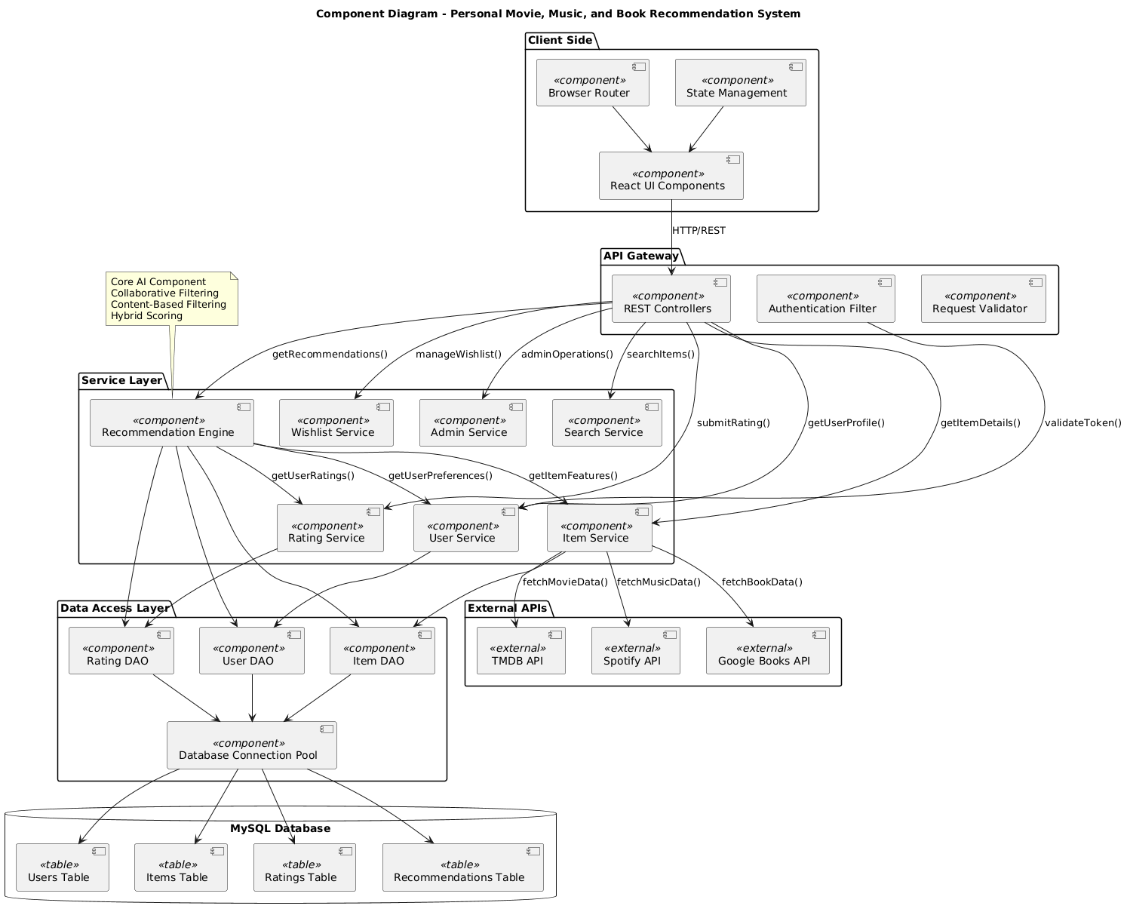
Figure 4-1: Component Diagram
HARDWARE/SOFTWARE MAPPING
The Diagram illustrates how the is Personal Movie, Music, and Book Recommendation System
distributed across different hardware nodes. our system is distributed across four types of nodes:
- Client Machines – The users' computers or phones running web browsers
- Application Server – Our main server running the backend logic
- Database Server – Where all our data is stored
- External API Servers – TMDB, Spotify, Google Books – we don't control these

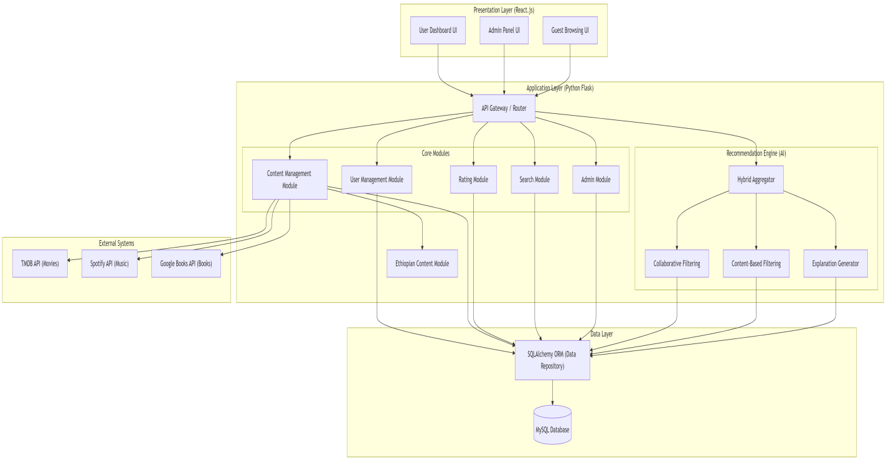
Figure 4-2: Component Diagram
4.3.3 Persistent Data Modeling
Persistent data modeling is about how the system captures, stores, and manages data so that it stays available, consistent, and safe. Unlike temporary session data, things like user profiles, content items, ratings, and recommendation histories must be stored securely to support long term personalization. This section covers our database selection and the main tables we designed.
Database Selection
We chose MySQL as our primary database. This decision aligns with the structured nature of our data and the needs of our recommendation algorithms. MySQL enforces strict relationships between entities like users, items, and ratings. Foreign key constraints ensure that every rating connects to a real user and a real item, preventing orphaned records. ACID compliance means critical operations like rating submissions happen atomically. If a user rates an item, the rating is saved and the item's average rating is updated. Either both happen or neither happens, preventing data corruption.
MySQL also supports the complex analytical queries needed for collaborative filtering, such as finding users with similar rating patterns. The well-defined relationships between users, books, movies, and music map naturally to relational tables, making the data model intuitive and maintainable. Our team already has practical experience with MySQL from coursework, which reduces technical risk.
Database Schema
The database is organized into several logical groups of tables that work together to support the recommendation ecosystem.
User Management Tables
The User table acts as the central authentication and profile storage layer. It stores core user credentials including email and a securely hashed password. Each user has a unique identifier that links to all their activities in the system. A status field manages account states such as active, inactive, suspended, or deleted.
The User Preferences table tracks which genres a user prefers in books, movies, and music, along with a weight value indicating preference strength. These weights are automatically updated based on the user's rating patterns. Each preference record links to a specific user through a foreign key.
Content Management Tables
The Items table serves as the core content table. It stores attributes common to all content types including title, description, release year, language, and cover image. A type field indicates whether the item is a book, movie, or music. This table also includes denormalized fields for average rating and rating count, updated automatically by database triggers for fast access.
The Books table extends the items table with book specific attributes like author, ISBN, page count, publisher, and genre. Each book record has a one to one relationship with its corresponding item record.
The Movies table extends the items table with movie specific attributes like director, duration in minutes, main cast, and content rating. Cast information is stored as text for simplicity while still enabling basic search.
The Music table extends the items table with music specific attributes like artist, album name, genre, duration in seconds, and track number. This includes Ethiopian genres like Tizita and Bati, supporting both international and local content.
Rating and Feedback Tables
The Ratings table records user ratings for items. This is the most critical data source for collaborative filtering algorithms. It stores which user rated which item, the score from 1 to 5 stars, an optional text review, and timestamps. The table enforces that each user can rate a specific item only once. If a user submits another rating for the same item, the existing rating is updated instead of creating a duplicate. Database triggers automatically recalculate the average rating and rating count in the items table whenever ratings are added, updated, or deleted.
Recommendation Tables
The Recommendations table stores pre computed recommendations for each user. This allows recommendations to be retrieved quickly without rerunning expensive algorithms on every request. The table contains the recommended item, a confidence score, display rank, which algorithm generated it, and a human readable explanation. Each recommendation has an expiration timestamp to ensure freshness.
The Recommendation Feedback table tracks how users interact with recommendations. It records whether users clicked on recommendations, whether they subsequently rated the recommended items, and what scores they gave. This data enables continuous algorithm refinement and helps us calculate metrics like click through rates.
System Support Tables
The Admin Logs table tracks administrative actions for security auditing and troubleshooting. It records which admin performed what action, when, and from which IP address. The API Cache table stores responses from external APIs like TMDB, Spotify, and Google Books. This reduces API calls, helps us stay within rate limits, and keeps the system functional even when external APIs are temporarily unavailable.

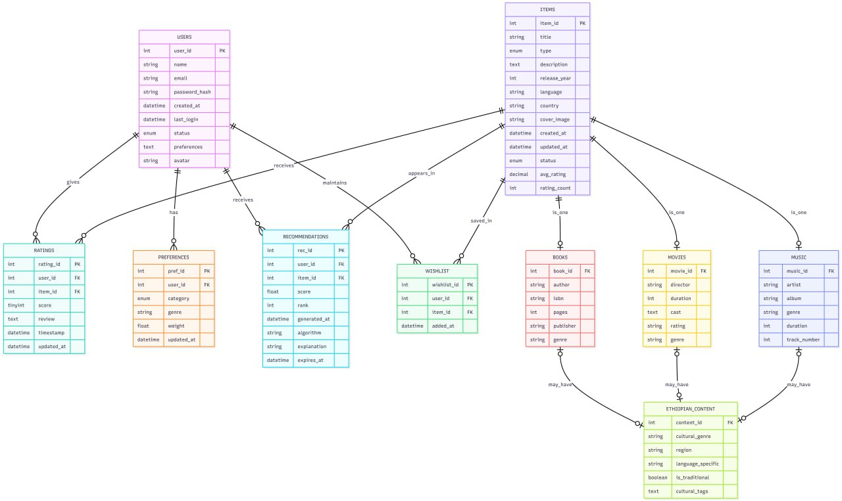

Figure 4-3 ER diagram1

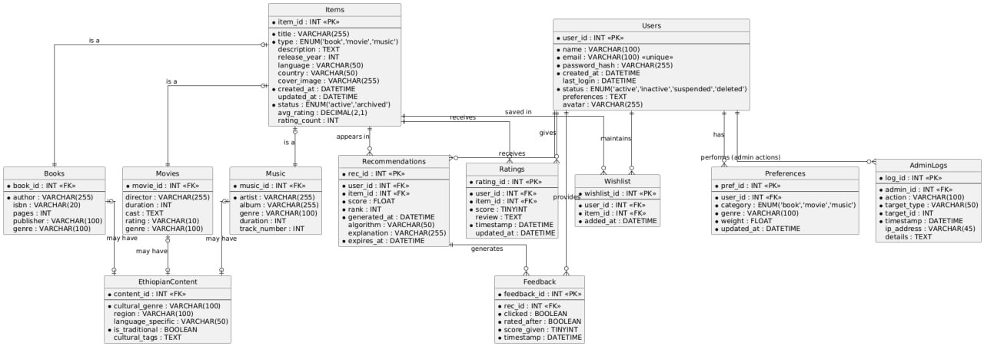
Figure 4-4 ER diagram2
Description of Relations in the ER Diagram:
The Entity-Relationship (ER) Diagram illustrates the logical structure of the database with the following key associations:
User to Ratings: A one-to-many (1:M) relationship exists between User and Ratings. One user can rate many items, but each rating belongs to exactly one user.
Item to Ratings: A one-to-many (1:M) relationship exists between Item and Ratings. One item can receive many ratings from different users, but each rating is associated with exactly one item.
User to Preferences: A one-to-many (1:M) relationship exists between User and Preferences. One user can have multiple genre preferences, but each preference belongs to exactly one user.
Item to Books/Movies/Music: A one-to-one (1:1) relationship exists between Item and each type-specific table. Each item has exactly one corresponding record in either Books, Movies, or Music table.
User to Recommendations: A one-to-many (1:M) relationship exists between User and Recommendations. The system generates multiple recommendations for each user, but each recommendation belongs to exactly one user.
Item to Recommendations: A one-to-many (1:M) relationship exists between Item and Recommendations. An item can be recommended to many different users, and each recommendation references exactly one item.
Recommendations to Feedback: A one-to-many (1:M) relationship exists between Recommendations and Feedback. Each recommendation can generate multiple feedback records from user interactions.
Referential Integrity: All relationships are enforced through foreign key constraints. If a user deletes their account, all associated ratings, preferences, recommendations, and feedback are automatically removed. Items cannot be deleted if they have existing ratings.
4.3.4 ACCESS CONTROL AND SECURITY
The system implements a comprehensive Role-Based Access Control (RBAC) mechanism designed to maintain the integrity of the recommendation platform and protect user data. By enforcing strict separation of privileges, the architecture ensures that users interact only with features relevant to their role, safeguarding sensitive personal information from unauthorized access.
Role | Privileges and Access Rights
Guest (Unregistered User) | Content Browsing: View public content including popular items and category listings without any personalization.  Search Access: Perform basic searches across books, movies, and music to discover content.  View-Only: Access item details and average ratings but cannot rate items or receive personalized recommendations.  Limited Interaction: Cannot create profiles, submit ratings, or access any user-specific features.
Registered User | Profile Management: Create and maintain personal profile with preferences and account settings. Full control over own account data.  Rating and Review: Submit ratings (1-5 stars) for any item, write optional text reviews, and update or delete their own ratings at any time.  Personalized Recommendations: Receive AI-generated recommendations based on rating history and preferences, with explanations for why items are suggested.  Preference Control: View and manage genre preferences across books, movies, and music, with automatic updates based on rating patterns.  Data Ownership: Access complete rating history, update profile information, and permanently delete own account with all associated data.
Administrator | Content Management: Add, update, and delete books, movies, and music items in the system. Manually input Ethiopian content not available through APIs.  User Administration: View registered users, suspend inappropriate accounts, and manage user-related issues while respecting privacy.  System Oversight: Access admin dashboard with usage analytics, monitor system performance, and review audit logs.  Content Curation: Ensure content quality by editing or removing inappropriate items, and manage genre classifications.  API Management: Monitor external API usage and manually trigger content updates when needed.

Security Implementation Measures
To ensure a secure, trusted, and resilient digital environment, the system incorporates the following industry-standard security protocols:
• Session-Based Authentication:
The system utilizes server-side session management for secure user authentication. Upon successful login, the server creates a unique session and stores the session ID in an HTTP-only cookie sent to the client. Sessions automatically expire after 30 minutes of inactivity, and users can manually log out to destroy sessions immediately.
• Cryptographic Password Hashing:
User credentials are never stored in plain text. The system employs the Bcrypt hashing algorithm with 12 salt rounds to encrypt passwords before storage, protecting accounts against brute-force attacks and rainbow table exploits.
• SQL Injection Prevention:
All database queries use parameterized statements through SQLAlchemy ORM, ensuring user input is never concatenated directly into SQL strings. Input validation occurs at both client and server levels.
• Cross-Site Scripting (XSS) Protection:
User-generated content is sanitized before storage using the Bleach library and HTML-encoded when displayed. HTTP-only cookies prevent JavaScript from accessing session tokens.
• Privacy-Preserving Data Design:
User email addresses are never publicly displayed. The system collects only essential information (name, email, ratings). Users can permanently delete their accounts, removing all associated data.
• End-to-End Encryption (SSL/TLS):
All data transmission between client and server is encrypted using HTTPS with a valid SSL certificate. HTTP requests are automatically redirected to HTTPS.
• Database Security and Isolation:
The MySQL database accepts connections only from the application server, never from the public internet. Database users operate on least privilege principle.
• Rate Limiting and Brute-Force Protection:
Login endpoints allow maximum 5 failed attempts per 15 minutes from a single IP address before temporary blocking.
• Admin Security and Auditing:
Admin accounts are created manually, not through registration. All administrative actions are logged with timestamps, IP addresses, and action details for audit trails.
4.3.5 DETAILED CLASS DIAGRAM
The detailed class diagram illustrates the object-oriented architectural design of the Personal Movie, Music, and Book Recommendation System. It defines the attributes (data) and methods (logic) for each component, enforcing a strict separation of concerns. The design utilizes an inheritance hierarchy where the Item class serves as the base for Book, Movie, and Music, ensuring a unified content structure across all domains.
A central feature of this model is the Recommendation Engine class, which encapsulates the collaborative filtering and content-based algorithms to generate personalized suggestions by comparing user preferences with item attributes. The User class acts as the system's primary actor, maintaining profiles, ratings, and preferences that feed into the recommendation logic.

4.3.6 Package Diagram
The system's codebase is organized into modular packages. This ensures separation of concerns, scalability, and maintainability. Each package handles specific functionalities and communicates with others through well-defined interfaces.
Presentation Layer Packages
The UI Components package contains reusable React components used across multiple pages. This includes navigation elements, content cards, rating widgets, search bars, mood selectors, and recommendation sections. These building blocks are designed to be modular and composable for consistent user interface construction.
The UI Pages package contains the main page components corresponding to different routes in the application. This includes the home page, login page, register page, dashboard page, browse page, item detail page, profile page, and admin page. Each page combines multiple UI components to create complete views.
The UI Router package handles client side routing and navigation. It defines route configurations and protected routes that require authentication, mapping URLs to the appropriate page components.
The UI Styles package contains all CSS stylesheets including main styles, responsive design rules for different screen sizes, theme definitions, and animations to enhance user experience.
The UI Utils package provides frontend utility functions including formatters for displaying dates and ratings, client side validators, constant definitions, and helper functions used across UI components.
Application Layer Packages
The Controllers package handles HTTP requests and responses. Controllers receive requests from the frontend, validate input, call appropriate services, and format responses. They contain no business logic, only request handling and response formatting. This includes controllers for authentication, users, items, ratings, recommendations, search, preferences, and admin functions.
The Services package contains the core business logic of the application. Services implement use cases, enforce business rules, and coordinate between controllers and data access objects. This includes authentication service, user management, item management, rating processing, search logic, preference management, and admin functions.
The Recommendation Engine package is the heart of the AI functionality. It contains all recommendation algorithms including collaborative filtering, content based filtering, hybrid approaches, mood based recommendations, and cross domain recommendation logic. It also includes explanation generation, model training, evaluation metrics, and recommendation caching.
The DAO package, or Data Access Objects, provides an abstraction layer between business logic and the database. Each DAO encapsulates all database operations for a specific entity, hiding SQL queries from the service layer. This includes DAOs for users, items, books, movies, music, ratings, preferences, recommendations, and feedback.
Data Layer Packages
The Models package contains SQLAlchemy ORM model classes that map directly to database tables. Each model defines the table structure, relationships, and database level constraints. This includes models for user, item, book, movie, music, rating, preference, recommendation, and feedback. The Migrations package contains database migration scripts that track schema changes over time. This allows the database structure to evolve while preserving data integrity. The Seeds package contains scripts for populating the database with initial data. This includes books, movies, and music from external APIs, plus sample users and ratings for testing and demonstration. The Database Configuration package handles database connection settings, session management, and base model classes to ensure consistent database access across the application. The Queries package contains optimized SQL queries for complex operations that are better expressed in raw SQL. These are used for performance critical tasks like building matrices for collaborative filtering.
Utilities and Support Packages
The Utils package provides cross cutting utilities used throughout the application. This includes input validators, helper functions, logging configuration, custom exception classes, and caching mechanisms. The Config package manages configuration settings for different environments including development, testing, and production. It separates configuration from code to allow deployment in various contexts. The External APIs package handles integration with external data sources. It includes client classes for TMDB for movies, Spotify for music, and Google Books APIs, plus response caching to reduce external calls and manage rate limits. The Tests package contains all test code. This includes unit tests for models, services, and the recommendation engine, plus integration tests for API endpoints and test fixtures. The Docs package maintains project documentation alongside the codebase. This includes API documentation, user manuals, and deployment guides.
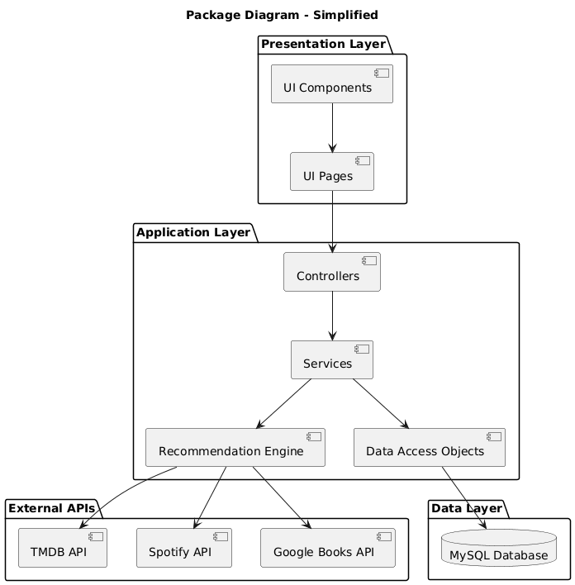

Figure 4-7: Package diagram
4.3.7 DEPLOYMENT
Deployment is the final step. We move the system from our computers to a real server where users can actually get to it. We use a three tier setup on university servers. The React frontend talks to the Flask backend through REST APIs. Everything stays on university owned servers so user data does not leave the institution.
The backend runs on Ubuntu 20.04 LTS from the university IT department. Nginx sits in front of Flask as a reverse proxy. Gunicorn runs the Flask app with multiple workers. The system is managed as a systemd service so it restarts if it crashes. All passwords and API keys are stored as environment variables, not in code. The React frontend goes through a production build to load faster. Nginx serves the files directly. It works on Chrome, Firefox, Edge, and Safari.
The database is MySQL 8.0. It only accepts connections from the application server. The database port is blocked from the public internet. We back up daily and every six hours. We pull data from TMDB, Spotify, and Google Books. We cache responses locally. For Ethiopian content not in those APIs, admins can add it manually.
When we deploy, we harden the server first. The firewall allows only the ports we need. We turn off password SSH and use keys instead. We install an SSL certificate for HTTPS. We create a dedicated database with its own user that has limited permissions. We pull code from GitHub, create a Python virtual environment, and install dependencies. We set up Gunicorn and Nginx, then build the React app. We add API keys to environment variables and run scripts to fetch initial data. We import Ethiopian content through the admin panel.
We test everything. All API endpoints, recommendation algorithms, load handling, security, and cross browser compatibility. Then we update DNS and set up monitoring for uptime, errors, and performance.
Once live, daily backups continue. Security updates run automatically. Logs rotate weekly. Monthly scripts fetch new content from APIs. User feedback gets reviewed weekly.
If Gunicorn crashes, systemd restarts it. If that fails, the admin gets an alert. If the database gets corrupted, we restore from backups. If the server hardware fails, we provision a backup server, restore the latest backup, deploy the code, and update DNS. Downtime is about four to eight hours.
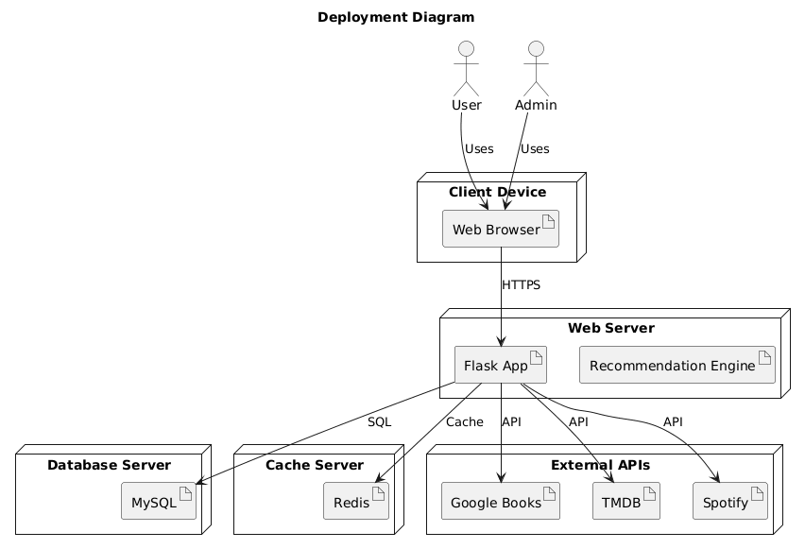
Figure 4-8: Deployment diagram

Reference
- Google. (2026). Google Books APIs. Retrieved from https://developers.google.com/books
- Last.fm. (2026). Last.fm API Documentation. Retrieved from https://www.last.fm/api
- Spotify. (2026). Spotify Web API Documentation. Retrieved from https://developer.spotify.com/documentation/web-api/
- The Movie Database. (2026). TMDB API Documentation. Retrieved from https://developers.themoviedb.org/3

